**Academy’s Wiki Channel – Analytics**

**IST659 - Project Milestone 2**

Sathish Kumar Rajendiran

Table of Contents

Executive Summary 2

A. Physical Database Design 2

B. Data Creation and Manipulation 3

C. Answering Data Questions 5

D. Data Samples, Implementation, Reflection & Summary 11

Conclusion 18

Appendix 18

## Executive Summary

Academy team has a Wiki Channel (online application) that contains number of articles on various topics having greater number of audiences. As the platform usage has been significantly increasing, it has become difficult to scale and meet growing demands of the audiences. In addition, Academy director also wanted to analyze and explore the usage to invest further on the expansion of this platform for both internal and external usage. However, there are no analytics on the platform usage to support the investing needs. Hence, Academy team has been seeking a database solution to track, analyze and improve the knowledge base and provide a seamless experience to the audiences (authors & followers).

## Physical Database Design

Following objects were created for this project. Repeatable script attached below, “IST659_WikiChannel_FinalProject_SQLs.sql” includes respective repeatable script for creating all tables, Views, functions and Stored procedure.

* **Tables**

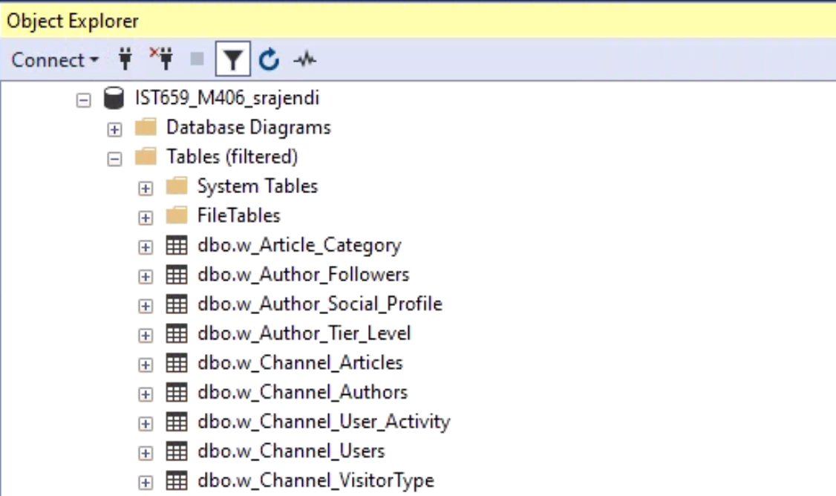

* **Views**

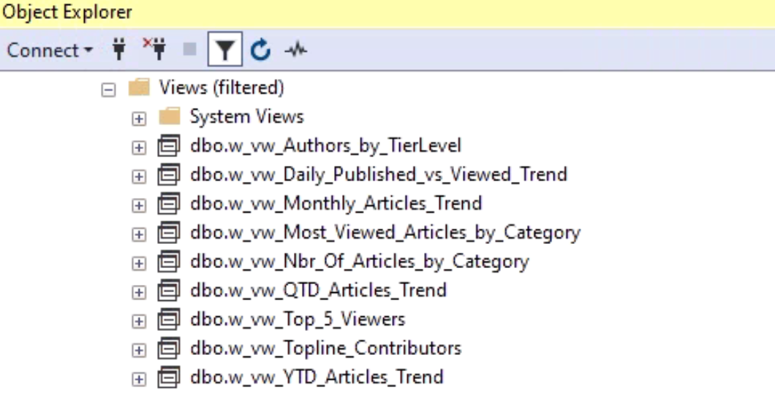

* **Scalar Functions**

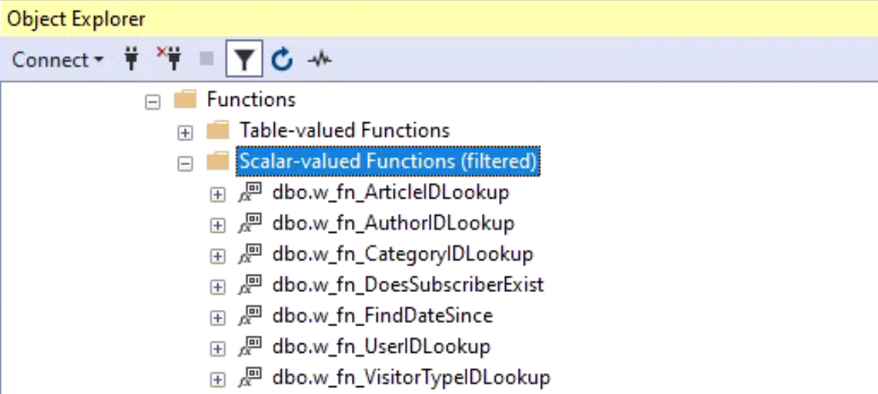

* **Stored Procedures**

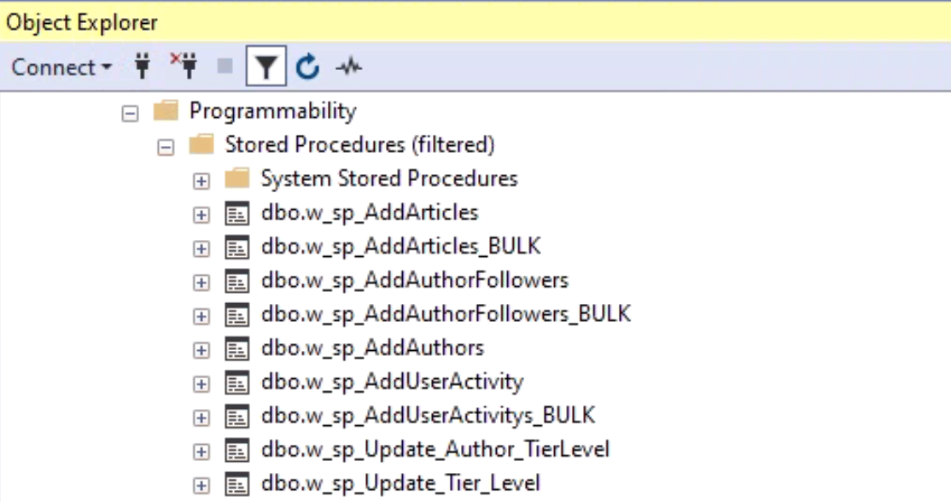

## Data Creation and Manipulation

Executing the ““IST659_WikiChannel_FinalProject_SQLs.sql” - does all the necessary DML operations Including INSERT, DELETE, UPATE statements. In addition, INSERT, UPDATE and/or DELETE statements are provided for all tables with detailed comments using named defaults and constraints; views, stored procedures and functions are also provided for data manipulation.

Example below,

* **Insert Statement to add Data into dbo.w_Article_Category**

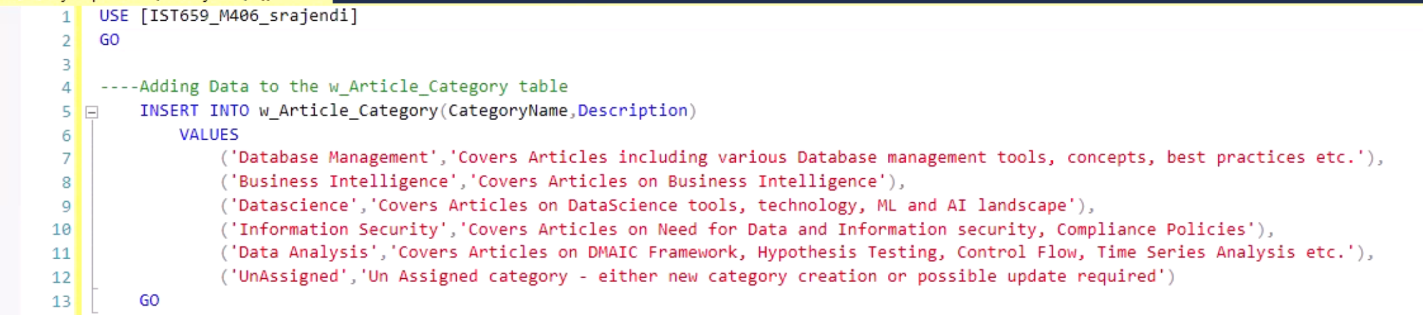

* **Select Statement to review the data availability**

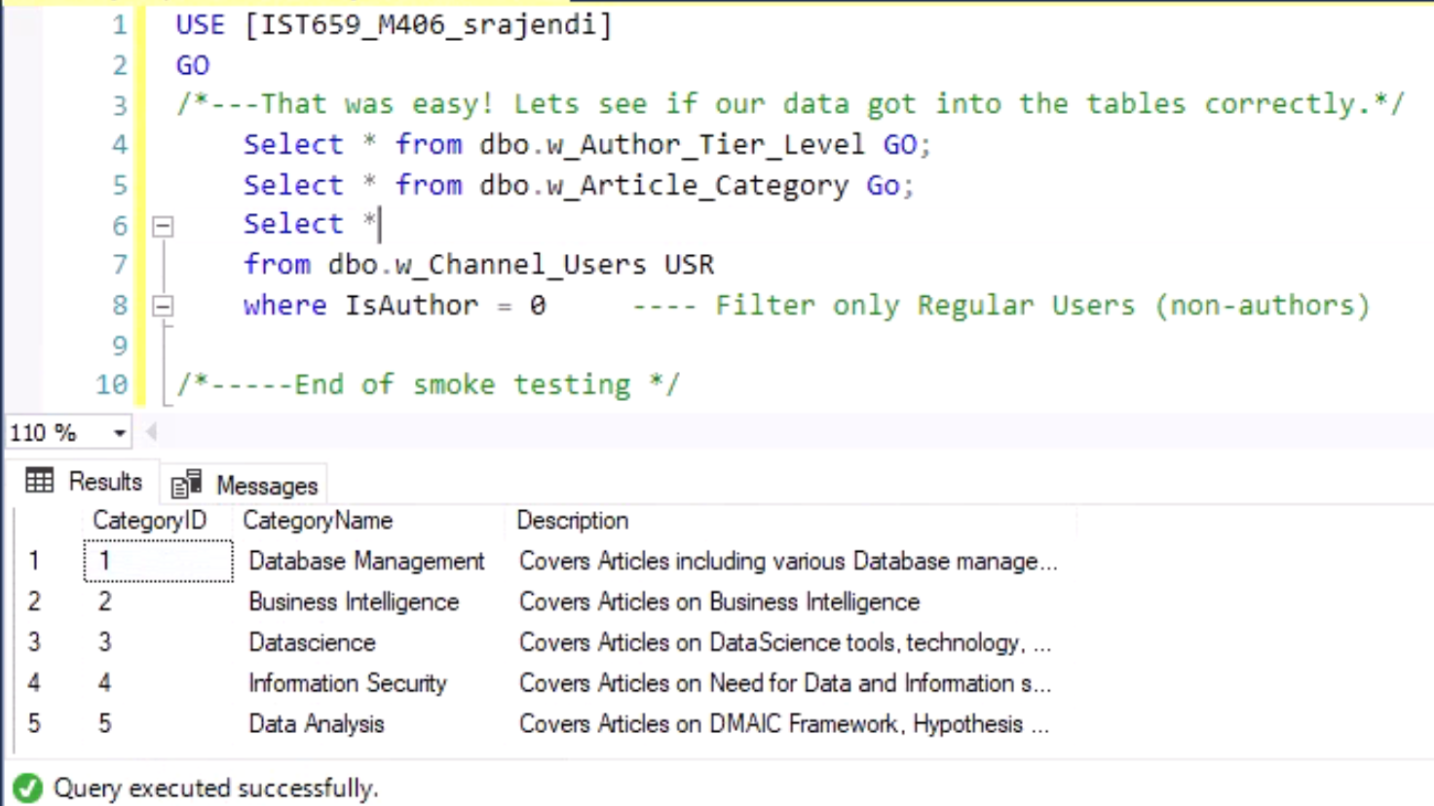

* **Delete Statement**

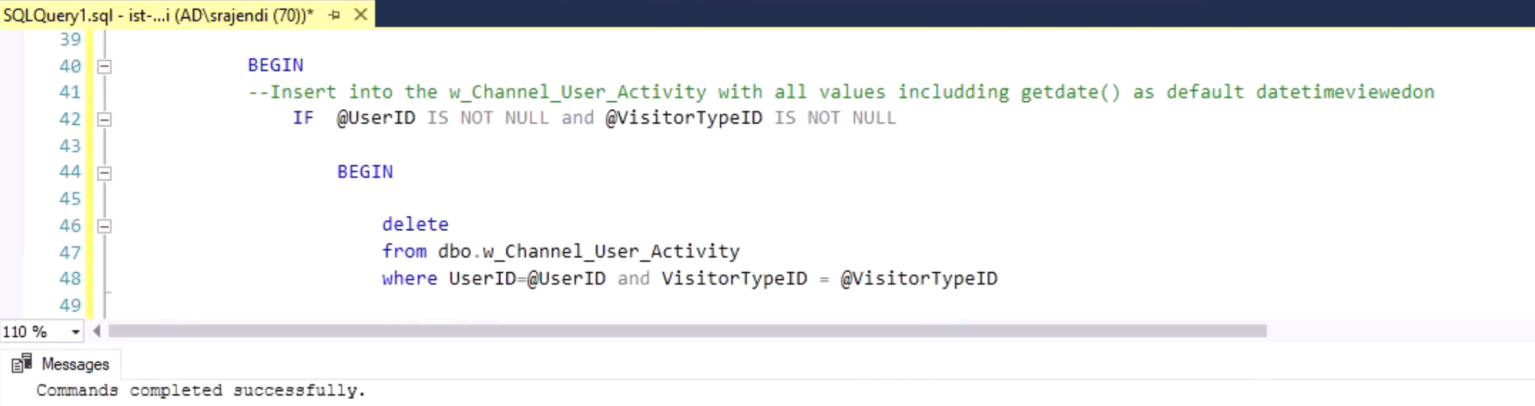

* **Update Statement to update TierLevel**

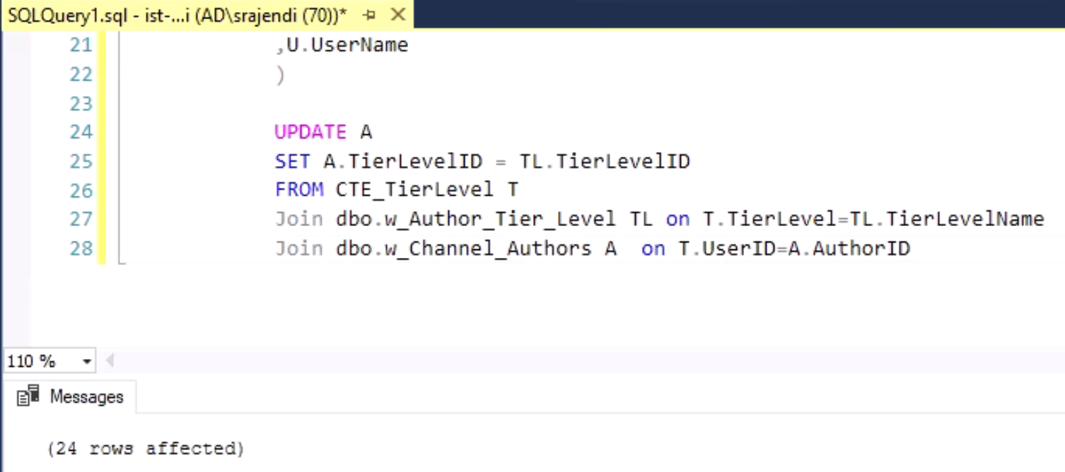

## Answering Data Questions

This section covers various data questions along with their respective SQL Statements.

In addition, SQL View has been created for all these data questions.

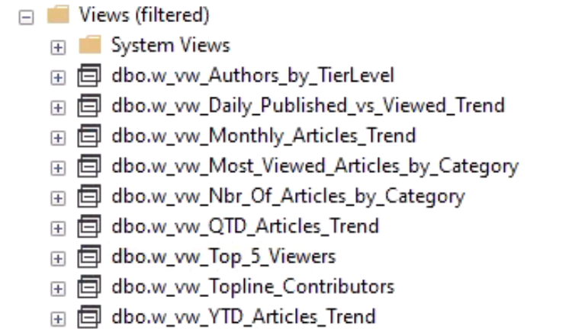

1. **Authors with greater number of followers**

USE [IST659_M406_srajendi]

GO

----Authors with greater number of Followers based on thier TierLevel

Select

U.UserName AuthorName

,T.TierLevelName

,T.Minimum_Followers

,count(F.UserID) as Current_Followers

from dbo.w_Author_Followers F

Join dbo.w_Channel_Authors A on F.AuthorID=A.AuthorID

Join dbo.w_Author_Tier_Level T on A.TierLevelID=T.TierLevelID

Join dbo.w_Channel_Users U on A.AuthorID=U.UserID

Group by

U.UserName

,T.TierLevelName

,T.Minimum_Followers

Order by Current_Followers desc

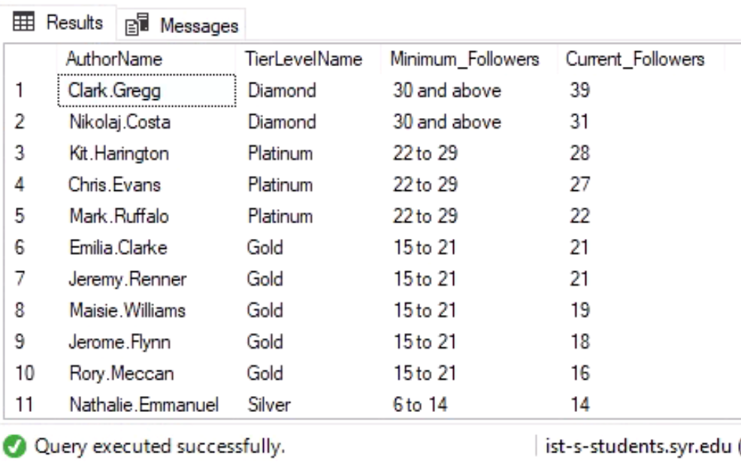

1. **Most Viewed Articles by Category**

USE [IST659_M406_srajendi]

GO

---Most Viewed Articles by Category

Select

C.CategoryName

, Count(Act.ArticleID) Articles_Viewed

From

dbo.w_Channel_User_Activity Act

Join dbo.w_Channel_Articles A on Act.ArticleID=A.ArticleID

Join dbo.w_Article_Category C on A.CategoryID = C.CategoryID

Group by C.CategoryName

Order by Articles_Viewed desc

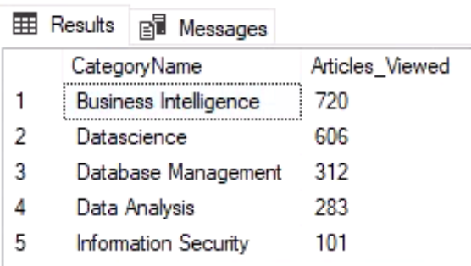

1. **Top 5 Viewers**

USE [IST659_M406_srajendi]

GO

---Select Top Viewers who has viewed the ariticles

Select top 5

U.UserName

,Count(A.ArticleID) Nbr_Of_Articles

From

dbo.w_Channel_User_Activity A

Join dbo.w_Channel_Users U on A.UserID=U.UserID

Where U.IsAuthor = 0

Group by U.UserName

GO

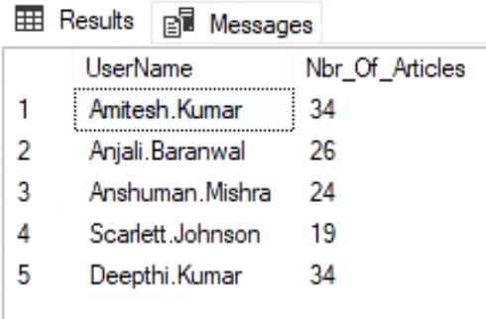

1. **Total number of Articles by Category**

USE [IST659_M406_srajendi]

GO

---Select total number of Articles by Category

Select

C.CategoryName

, Count(A.ArticleID) Nbr_Of_Articles

From

dbo.w_Channel_Articles A

Join dbo.w_Article_Category C on A.CategoryID = C.CategoryID

Group by C.CategoryName

Order by Nbr_Of_Articles

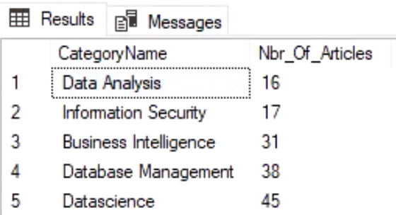

1. **Premium level contributors**

USE [IST659_M406_srajendi]

GO

---Authors with more than equal to 10 number of Artilces publihed.

Select

U.UserName as AuthorName

, Count(A.ArticleID) Nbr_Of_Articles

From

dbo.w_Channel_Articles A

Join dbo.w_Channel_Users U on A.AuthorID = U.UserID

Where U.IsAuthor = 'true'

Group by U.UserName having Count(A.ArticleID) >=10

Order by Nbr_Of_Articles desc

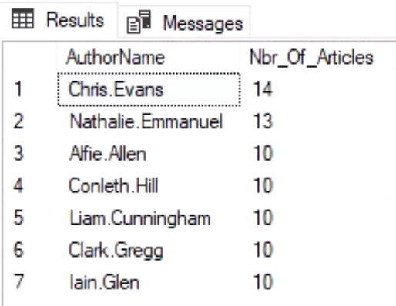

1. **Daily Trend: Articles Published vs Viewed**

USE [IST659_M406_srajendi]

GO

------Find out the trend between Number of Articles Published vs Viewed on Week Day basis

WITH Articles_Published_vs_Viewed

AS

(Select

Datepart(dw,Act.DateTimeViewedOn) As Days_of_Week

, Datename(dw,Act.DateTimeViewedOn) As Day_of_Week

, Count(Act.ArticleID) As Articles_Viewed

, 0 As Articles_Published

From

dbo.w_Channel_User_Activity Act

Group by Datepart(dw,Act.DateTimeViewedOn),Datename(dw,Act.DateTimeViewedOn)

UNION ALL

Select

Datepart(dw,A.DatePublished) As Days_of_Week

, Datename(dw,A.DatePublished) As Day_of_Week

, 0 As Articles_Viewed

, Count(A.ArticleID) As Articles_Published

From

dbo.w_Channel_Articles A

Group by Datepart(dw,A.DatePublished),Datename(dw,A.DatePublished)

)

Select

Days_of_Week,Day_of_Week

, sum(Articles_Published) as Articles_Published

, sum(Articles_Viewed) as Articles_Viewed

From Articles_Published_vs_Viewed

Group by Days_of_Week,Day_of_Week

order by Days_of_Week

GO

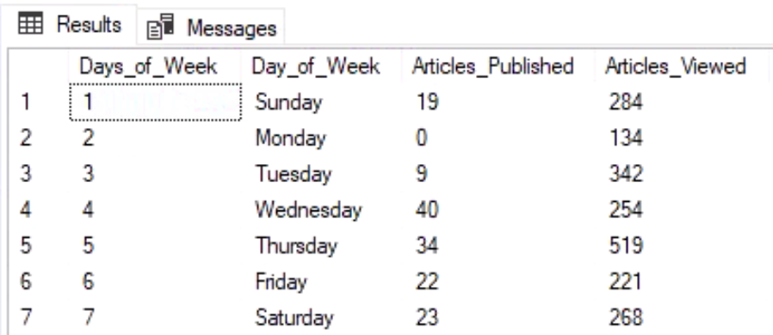

1. **Quarterly Trend: Number of Articles Published**

USE [IST659_M406_srajendi]

GO

------Quarterly trend of Number of Articles Published

Select

Datepart(year,A.DatePublished) As Year_Published

,'Q'+ cast(Datepart(quarter,A.DatePublished) as varchar) As Quarter_Published

,Count(A.ArticleID) Nbr_Of_Articles

From

dbo.w_Channel_Articles A

Group by Datepart(year,A.DatePublished),Datepart(quarter,A.DatePublished)

Order by Quarter_Published

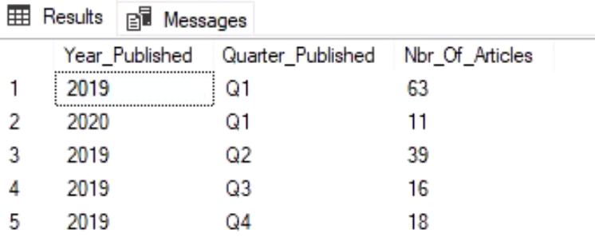

## **Data Samples, Implementation, Reflection & Summary**

* **Data Samples**

----1. Data from dbo.w_Channel_Users table

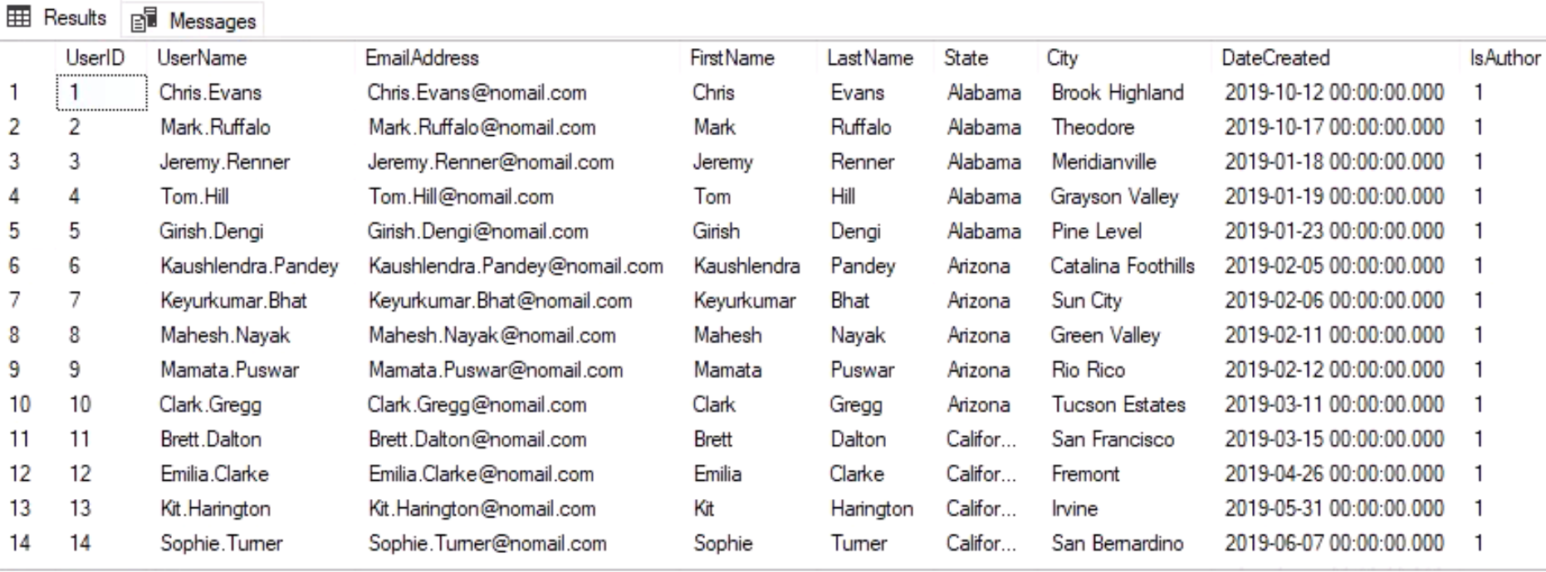

----2. Few Articles info

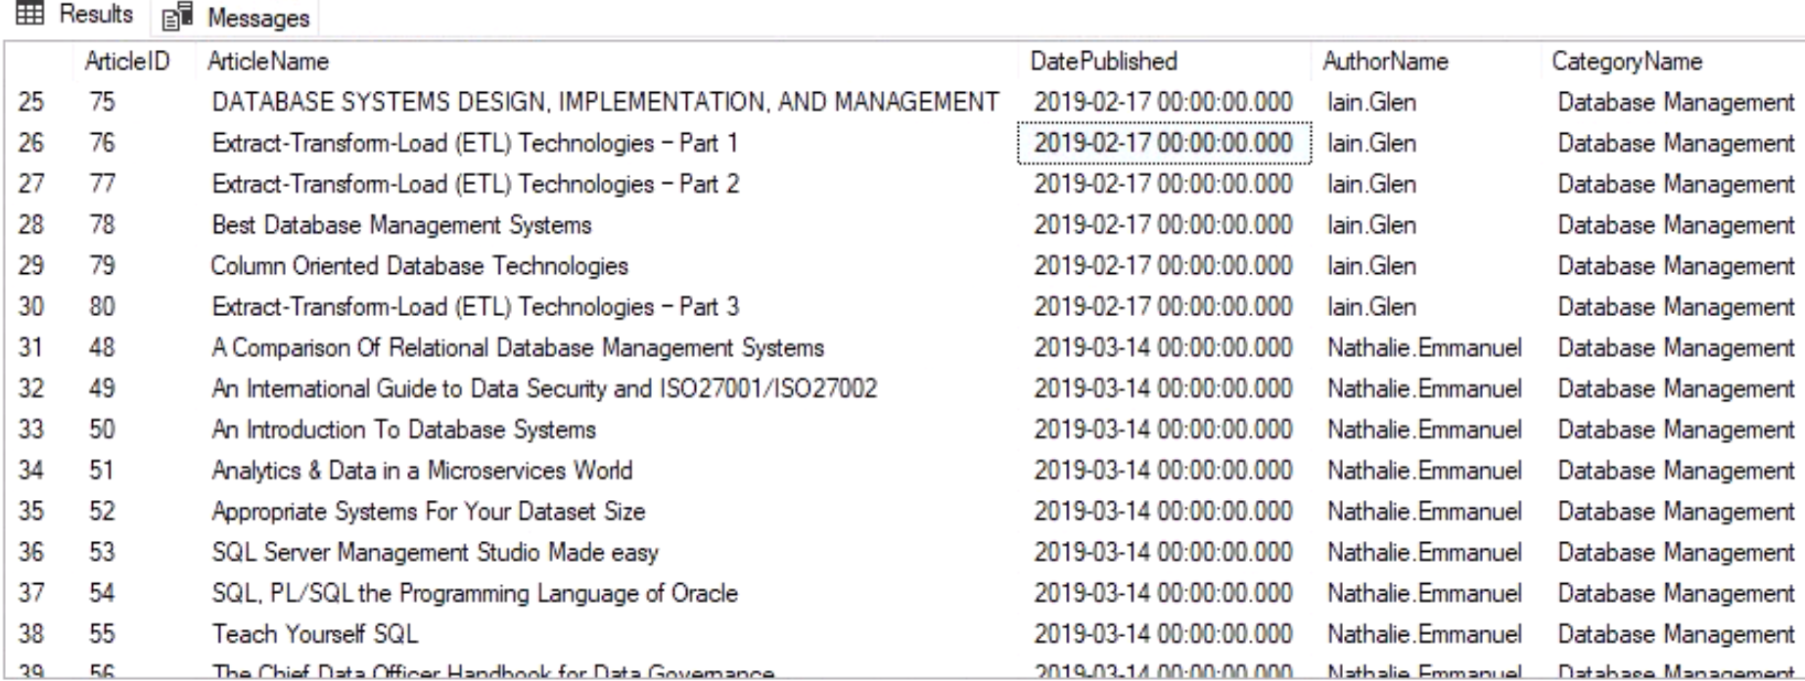

* **Reports**

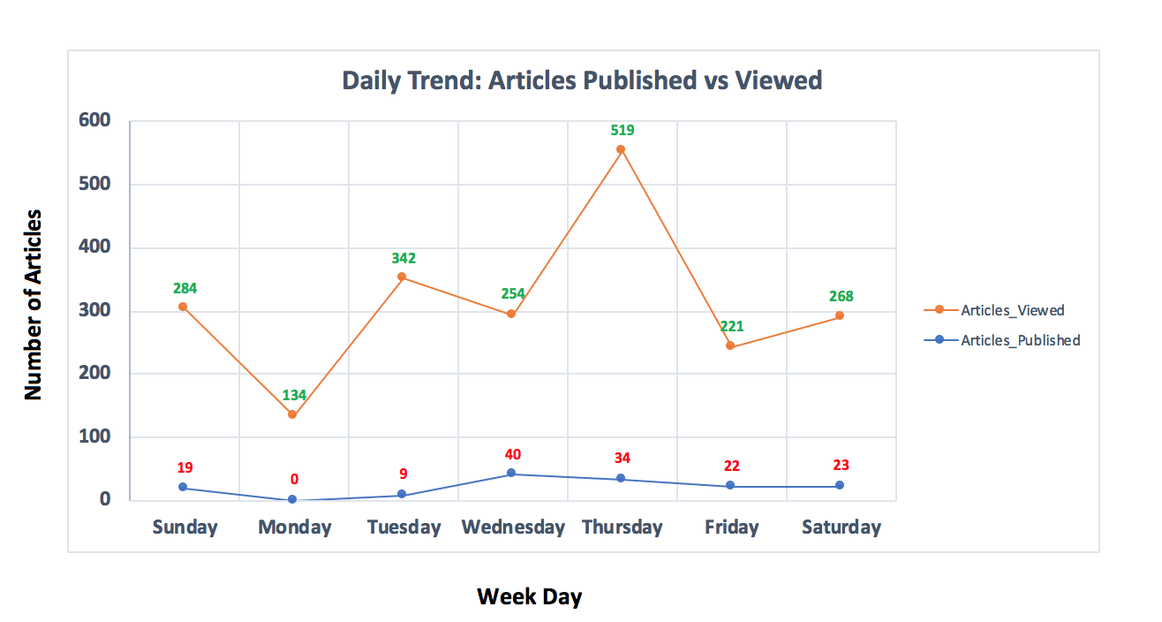

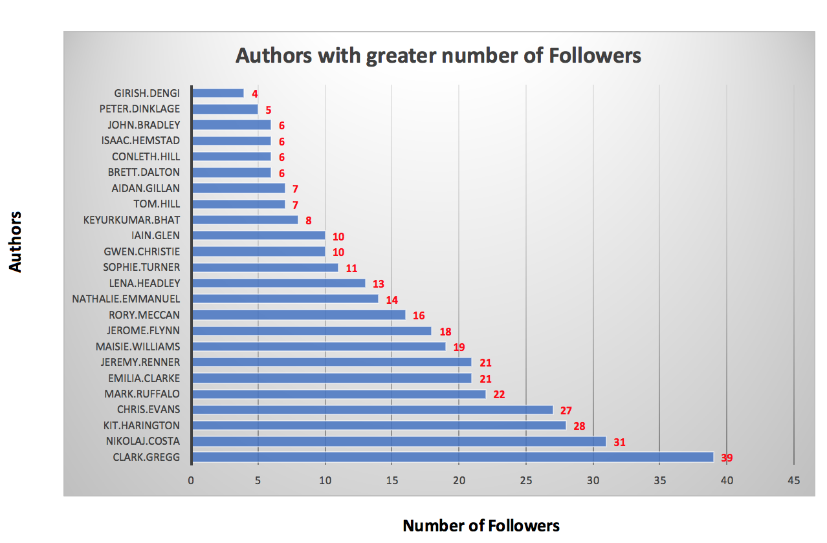

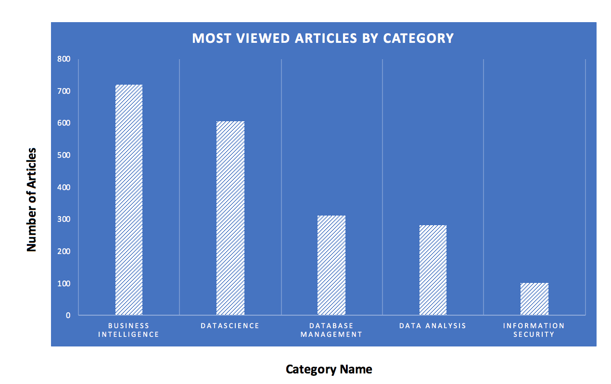

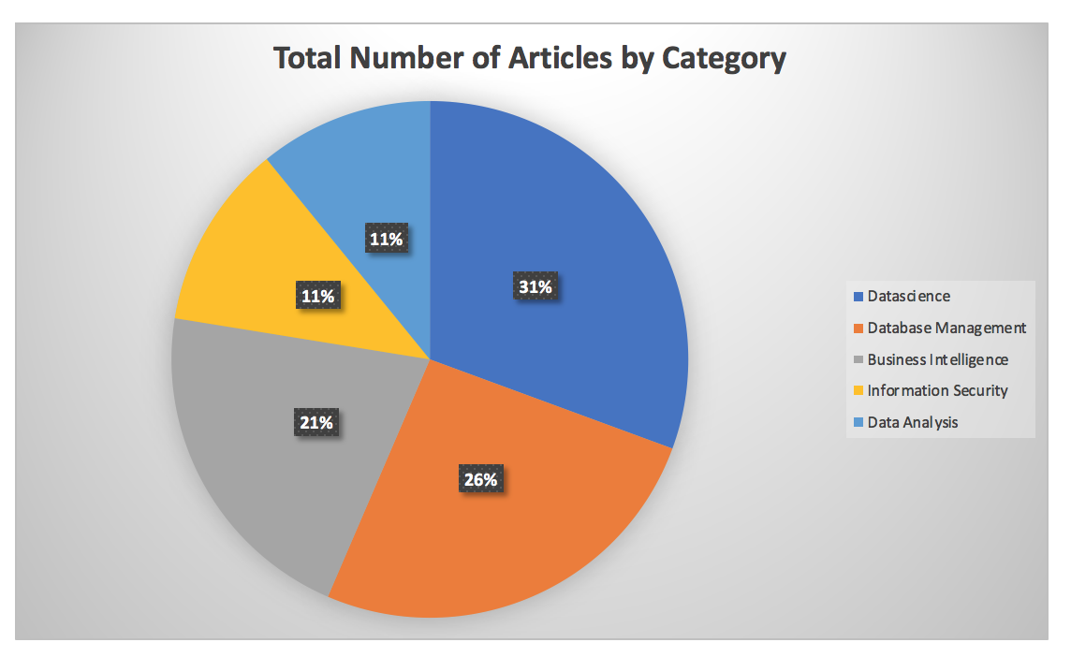

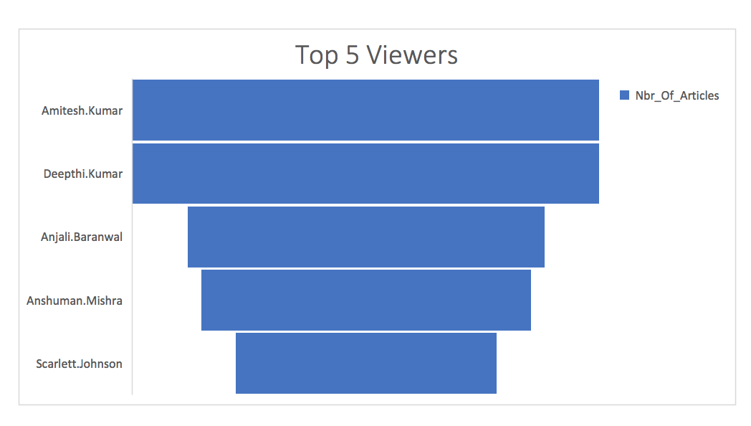 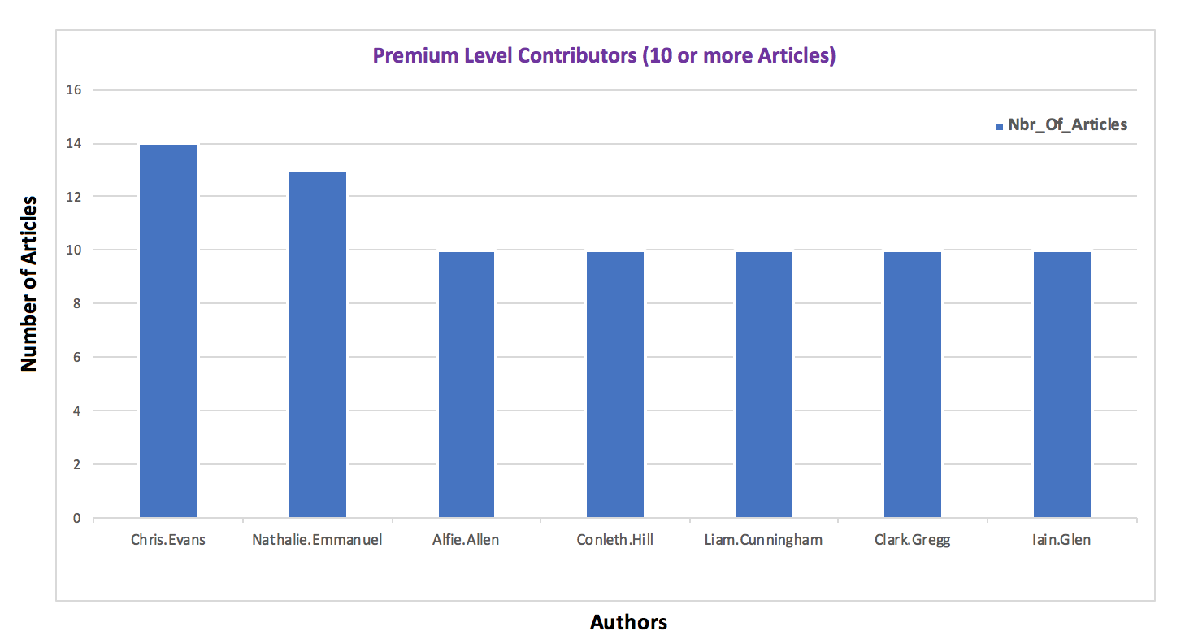

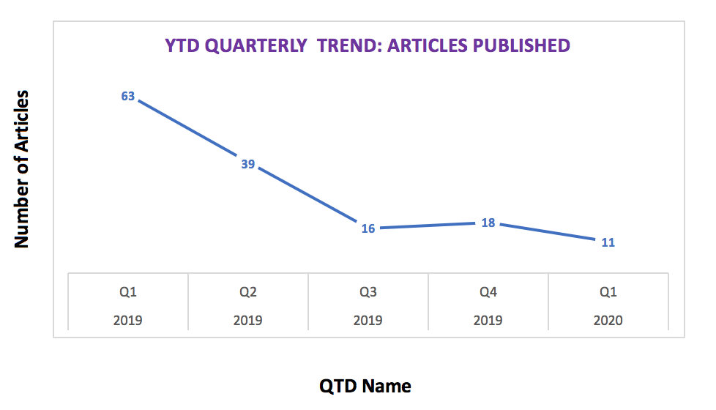

* **Create an Access Form to manage Article’s Categories**

Following section illustrates a design of a simple UI using Access to make changes to an Article’s Category

* Connect to ODBC Source from Access and Import Join dbo.w_Article_Category & dbo.w_Channel_Articles table tables
* Join these objects as 1: Many between CategoryID from dbo.w_Article_Category to CategoryID on dbo.w_Channel_Articles table.

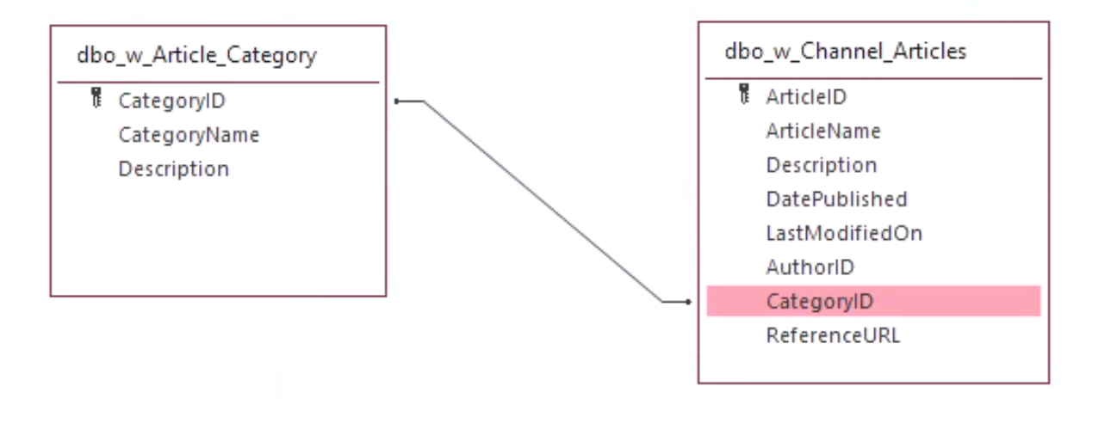

* View the data from both objects in Access

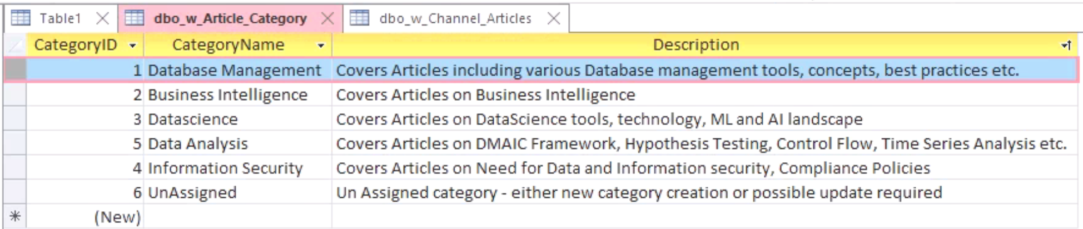

* Design a Form/Sub-Form to display Category/Article Information

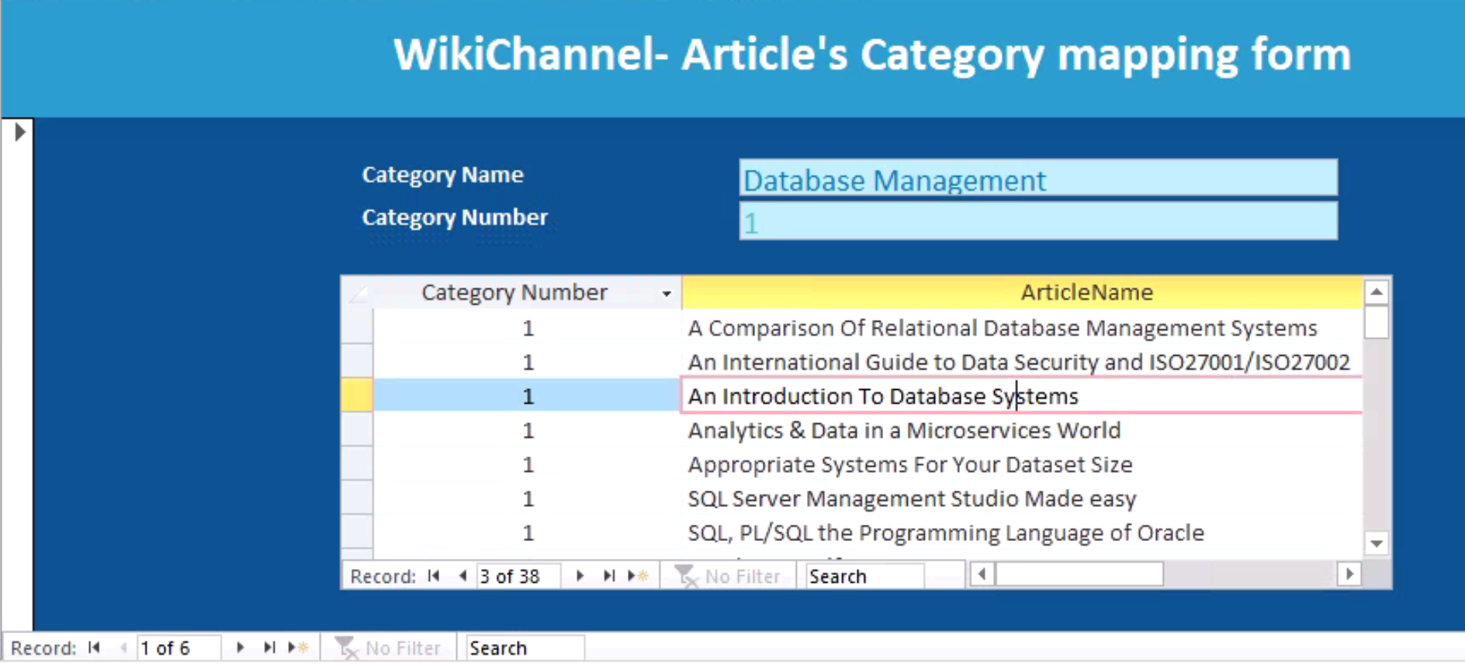

* Choose any Article by simply hovering over the rows.

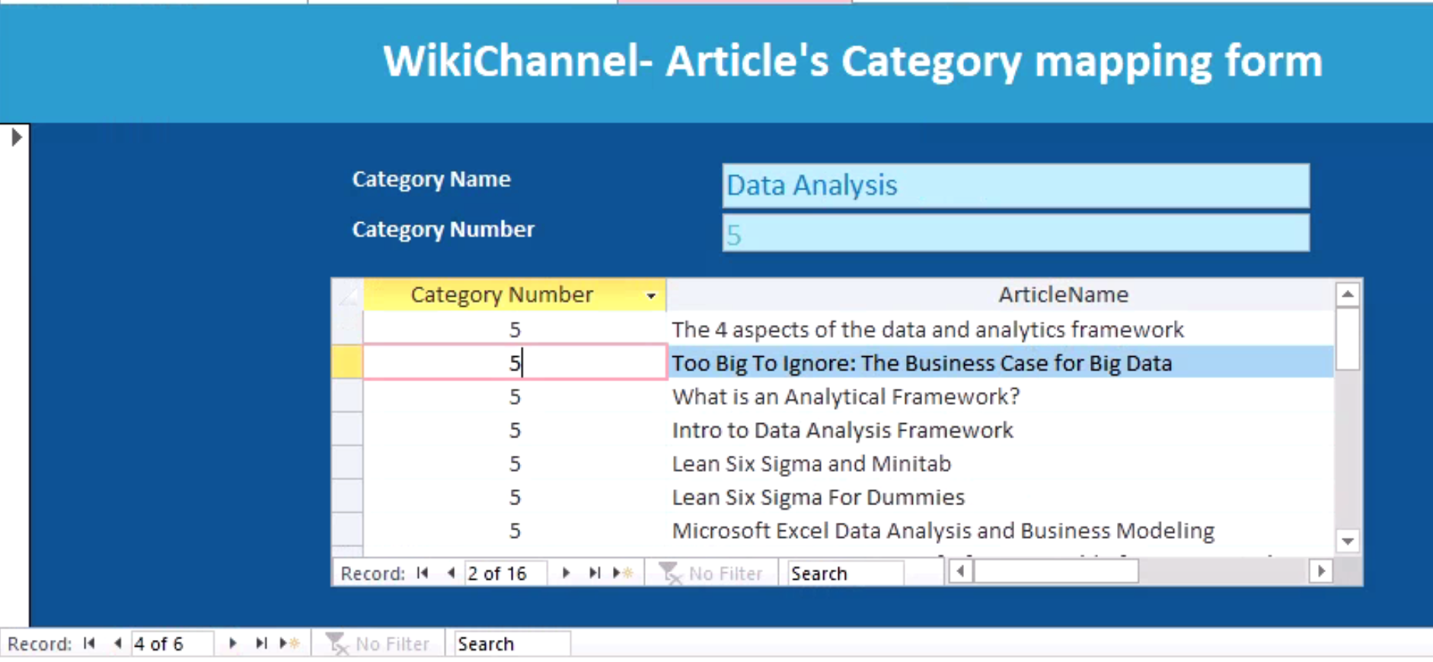

* Change the Category by Updating the Number

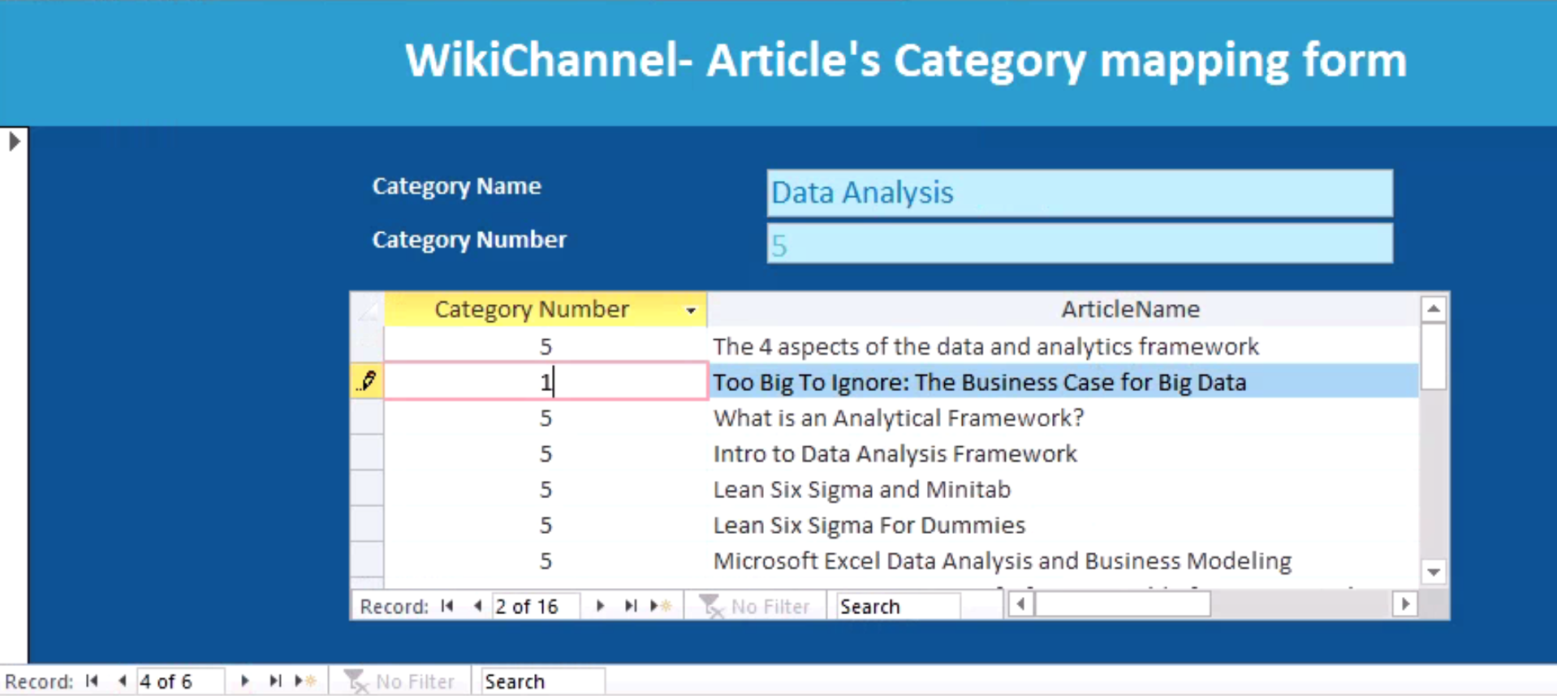

* If you go back to the Category that was updated to; you may find the article in there now. It has been successfully updated to new category.

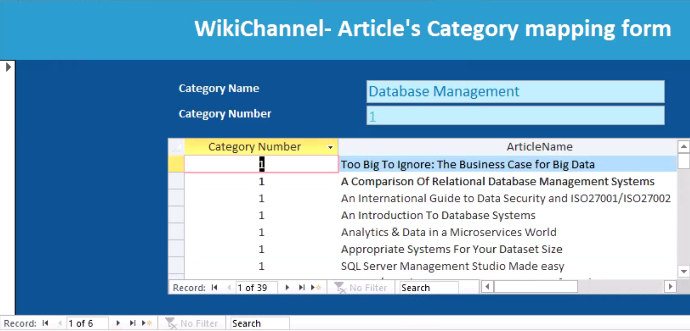

* Now, verify the same from SSMS by querying the tables.

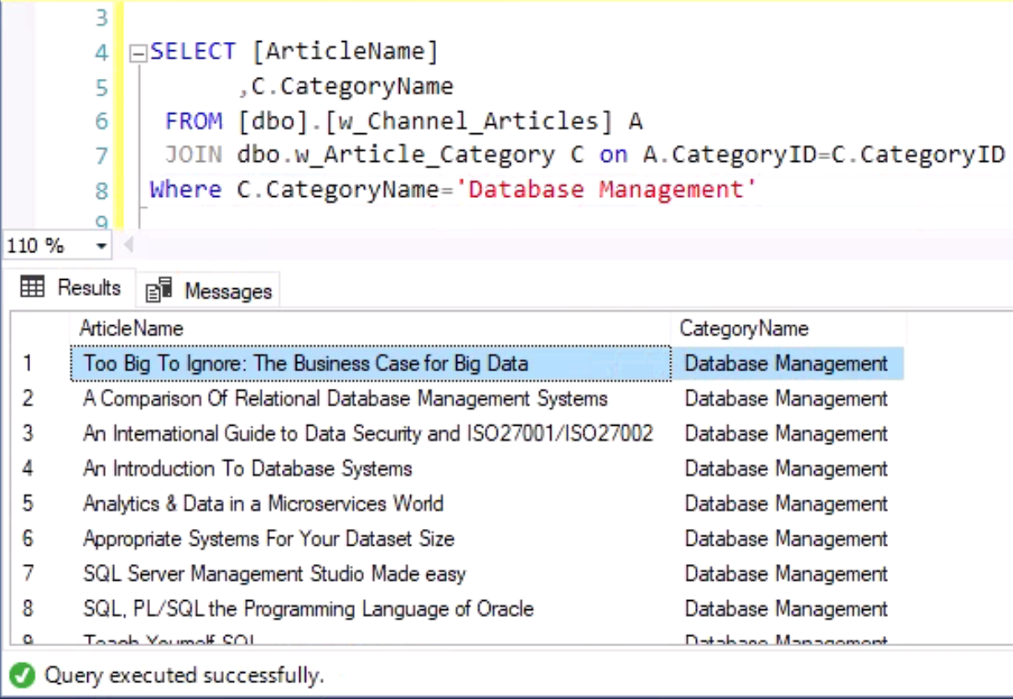

* **Reflection:**

Well,Last 10 weeks have contributed more than I had imagined. Even though, I have been working with Databases for more than a decade never really discussed topics at this depth and also in a structured manner. Especially, the normalization concept was made so easy to all of us. Both Professors made the journey fairly easy for us. I also, never really thought Conceptual Model is really the beginning of all and often we start with Loosely designed Logical Model and start building objects with Physical design. Going forward, I would be paying more attention to Conceptual model as its foundation of all.

In addition, this course also made a better programmer when it comes to creating Repeatable scripts. Realized the importance of having Comments, when to choose from UDFs to Views to Stored Procedures.

I have also programmed my very first R-Script in R-Studio and the lab exercises, Asynchronous materials made things lot easier. I can confidently say that my proficiency level on Database management has significantly improved and the execution of this Milestone project is proof of that. Thanks to our great professors, again!

## Conclusion

Yes, we were able to build an analytics solution to track, analyze and improve the academy’s knowledge base (Wiki Channel) usage to benefit its growing audiences. This project has touched upon several layers, Business Rules, Data Questions, Conceptual & Logical Models, Entity relationships through referential integrity, Various database Constraints, repeatable scripts for Objects & Data creation, data manipulation etc. In addition, Access Forms & R Studio showcased the aspects of engaging business users for data manipulation, Validation and Analytics. I should have spent more on R-Studio and with the knowledge gathered from this course would definitely help me choose the right database design, modeling and asking the right data questions.

## Appendix

Please review this section for the SQLs used in this project. These are composed as a repeatable script that can be run over multiple times without any issues.

**IST659_WikiChannel_FinalProject_SQLs.sql**

as follow,

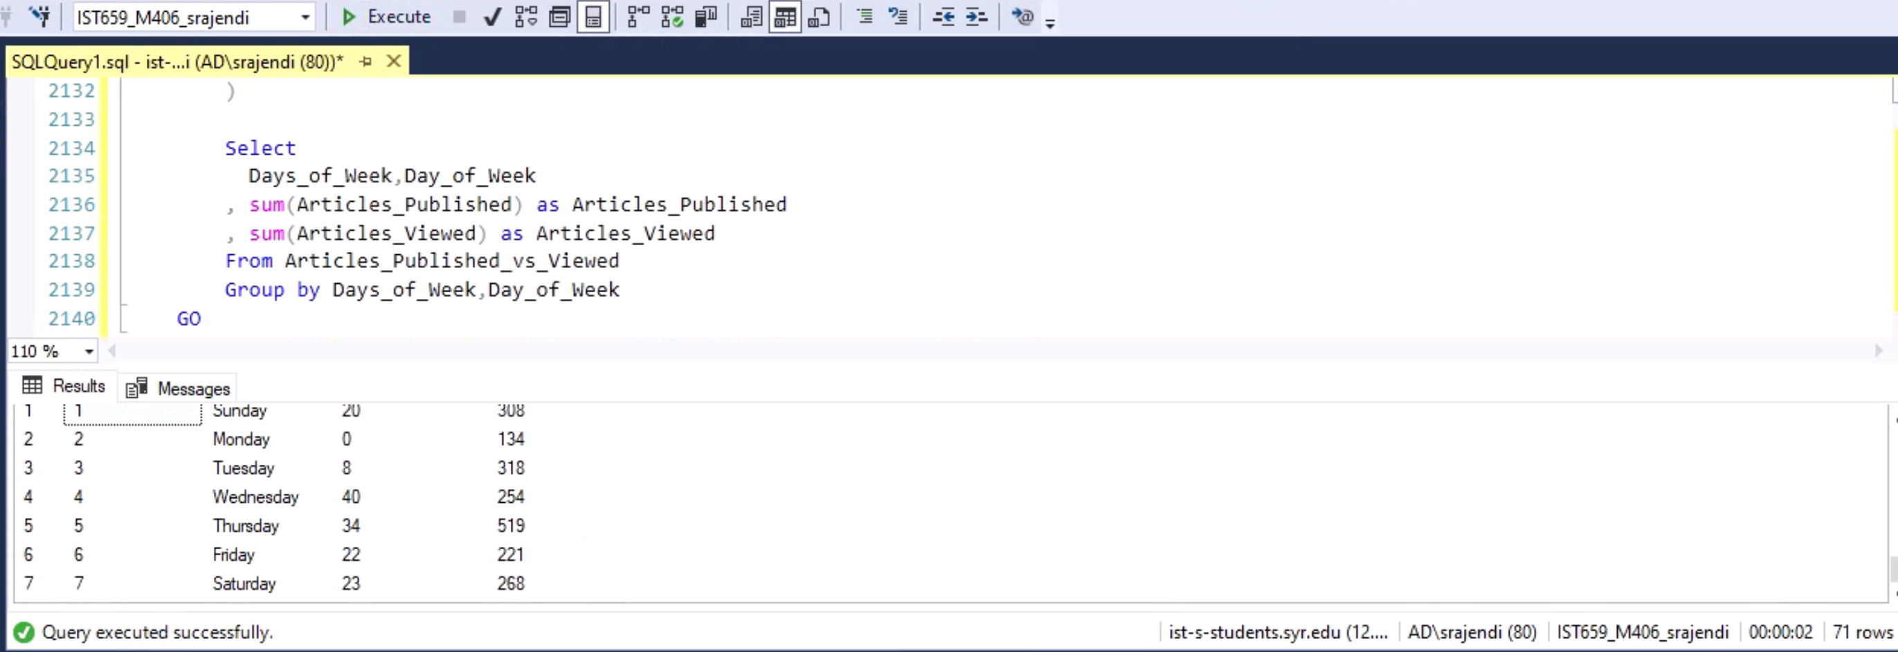

USE [IST659_M406_srajendi]

GO

/*****************************************************************************************************

Title : WikiChannel - Main Project

Author : Sathish Kumar Rajendiran

Course : IST659 M406

Term : March, 2020

Database Name: IST659_M406_srajendi

SQL Objects:

Tables: (In the Order of DROP Sequence) - Primary is available on All Tables

1. dbo.w_Author_Followers | FKey Contraints: 2 UKey Contraints: 1 (Composite)

2. dbo.w_Channel_User_Activity | FKey Contraints: 3 UKey Contraints: 1 (Composite)

3. dbo.w_Channel_Articles | FKey Contraints: 2 UKey Contraints: 1

4. dbo.w_Channel_Authors | FKey Contraints: 2 UKey Contraints: 1

5. dbo.w_Channel_Users | FKey Contraints: 0 UKey Contraints: 2

6. dbo.w_Article_Category | FKey Contraints: 0 UKey Contraints: 1

7. dbo.w_Author_Social_Profile | FKey Contraints: 0 UKey Contraints: 1

8. dbo.w_Author_Tier_Level | FKey Contraints: 0 UKey Contraints: 1

9. dbo.w_Channel_VisitorType | FKey Contraints: 0 UKey Contraints: 1

Views:

1. dbo.w_vw_Most_Viewed_Articles_by_Category

2. dbo.w_vw_Authors_by_TierLevel

3. dbo.w_vw_Nbr_Of_Articles_by_Category

4. dbo.w_vw_Top_5_Viewers

5. dbo.w_vw_Topline_Contributors

6. dbo.w_vw_YTD_Articles_Trend

7. dbo.w_vw_QTD_Articles_Trend

8. dbo.w_vw_Monthly_Articles_Trend

9. dbo.w_vw_Daily_Published_vs_Viewed_Trend

Functions:

1. dbo.w_fn_UserIDLookup

2. dbo.w_fn_AuthorIDLookup

3. dbo.w_fn_FindDateSince

4. dbo.w_fn_DoesSubscriberExist

5. dbo.w_fn_CategoryIDLookup

6. dbo.w_fn_ArticleIDLookup

7. dbo.w_fn_VisitorTypeIDLookup

Stored Procedures:

1. dbo.w_sp_AddAuthors

2. dbo.w_sp_AddAuthorFollowers

3. dbo.w_sp_AddArticles

4. dbo.w_sp_AddUserActivity

5. dbo.w_sp_Update_Tier_Level

6. dbo.w_sp_Update_Author_TierLevel

Additional Stored Procedures for BULK Data Entry

1. dbo.w_sp_AddAuthorFollowers_BULK

2. dbo.w_sp_AddArticles_BULK

3. dbo.w_sp_AddUserActivitys_BULK

**********************************************************************************************************

************************ Real Fun Begins *************************************************************

**********************************************************************************************************

Drop all user tables if exist

*********************************************************************************************************/

IF EXISTS (SELECT * FROM INFORMATION_SCHEMA.TABLES WHERE TABLE_NAME='w_Author_Followers')

BEGIN

DROP TABLE w_Author_Followers

END

GO

IF EXISTS (SELECT * FROM INFORMATION_SCHEMA.TABLES WHERE TABLE_NAME='w_Channel_User_Activity')

BEGIN

DROP TABLE w_Channel_User_Activity

END

GO

IF EXISTS (SELECT * FROM INFORMATION_SCHEMA.TABLES WHERE TABLE_NAME='w_Channel_Articles')

BEGIN

DROP TABLE w_Channel_Articles

END

GO

IF EXISTS (SELECT * FROM INFORMATION_SCHEMA.TABLES WHERE TABLE_NAME='w_Channel_Authors')

BEGIN

DROP TABLE w_Channel_Authors

END

GO

IF EXISTS (SELECT * FROM INFORMATION_SCHEMA.TABLES WHERE TABLE_NAME='w_Channel_Users')

BEGIN

DROP TABLE w_Channel_Users

END

GO

IF EXISTS (SELECT * FROM INFORMATION_SCHEMA.TABLES WHERE TABLE_NAME='w_Article_Category')

BEGIN

DROP TABLE w_Article_Category

END

GO

IF EXISTS (SELECT * FROM INFORMATION_SCHEMA.TABLES WHERE TABLE_NAME='w_Author_Social_Profile')

BEGIN

DROP TABLE w_Author_Social_Profile

END

GO

IF EXISTS (SELECT * FROM INFORMATION_SCHEMA.TABLES WHERE TABLE_NAME='w_Author_Tier_Level')

BEGIN

DROP TABLE w_Author_Tier_Level

END

GO

IF EXISTS (SELECT * FROM INFORMATION_SCHEMA.TABLES WHERE TABLE_NAME='w_Channel_VisitorType')

BEGIN

DROP TABLE w_Channel_VisitorType

END

GO

/*************************************************************************************************************

Time to Create all the Tables needed for this Project

Tables: (In the Order of DROP Sequence) - Primary is available on All Tables

1. dbo.w_Author_Followers | FKey Contraints: 2 UKey Contraints: 1 (Composite)

2. dbo.w_Channel_User_Activity | FKey Contraints: 3 UKey Contraints: 1 (Composite)

3. dbo.w_Channel_Articles | FKey Contraints: 2 UKey Contraints: 1

4. dbo.w_Channel_Authors | FKey Contraints: 2 UKey Contraints: 1

5. dbo.w_Channel_Users | FKey Contraints: 0 UKey Contraints: 2

6. dbo.w_Article_Category | FKey Contraints: 0 UKey Contraints: 1

7. dbo.w_Author_Social_Profile | FKey Contraints: 0 UKey Contraints: 1

8. dbo.w_Author_Tier_Level | FKey Contraints: 0 UKey Contraints: 1

9. dbo.w_Channel_VisitorType | FKey Contraints: 0 UKey Contraints: 1

**************************************************************************************************************

*********************** Table Creation - Begins ***********************************************************/

----- Creating the User table

----- This Table hosts all User information

----- Both Author and User Profile is managed here; Boolean Flag to differentiate User Type

----- UserName and EmailAddress are expected to have Unique values

CREATE TABLE w_Channel_Users (

--Columns for the User table

UserID int identity CONSTRAINT PK_w_Channel_Users PRIMARY KEY (UserID),

UserName varchar(40) not null CONSTRAINT U1_w_Channel_Users UNIQUE (UserName),

EmailAddress varchar(50) not null CONSTRAINT U2_w_Channel_Users UNIQUE (EmailAddress),

FirstName varchar(20),

LastName varchar(20),

State varchar(20),

City varchar(50),

DateCreated datetime not null default GetDate(),

IsAuthor bit not null default 'true'

)

GO

-----End Creating the User table

-----Creating the w_Article_Category table

----- This Table hosts Category Type of an Article

----- CategoryName expected to have Unique value

CREATE TABLE w_Article_Category (

--Columns for the w_Article_Category table

CategoryID int identity CONSTRAINT PK_w_Article_Category PRIMARY KEY (CategoryID),

CategoryName varchar(50) not null CONSTRAINT U1_w_Article_Category UNIQUE (CategoryName),

Description varchar(100)

)

GO

-----End Creating the w_Article_Category table

-----Creating the w_Author_Social_Profile table

----- This Table hosts Social Profile Values of Author

----- ProfileName expected to have Unique value

CREATE TABLE w_Author_Social_Profile (

--Columns for the w_Author_Social_Profile table

ProfileID int identity CONSTRAINT PK_w_Author_Social_Profile PRIMARY KEY (ProfileID),

ProfileName varchar(50) not null CONSTRAINT U1_w_Author_Social_Profile UNIQUE (ProfileName),

Description varchar(100)

)

GO

-----End Creating the w_Author_Social_Profile table

---Creating the w_Author_Tier_Level table

----- This Table hosts TierLevel Information for Authors based on the followers count

----- TierLevelName expected to have Unique value

CREATE TABLE w_Author_Tier_Level (

--Columns for the w_Author_Tier_Level table

TierLevelID int identity CONSTRAINT PK_w_Author_Tier_Level PRIMARY KEY (TierLevelID),

TierLevelName varchar(50) not null CONSTRAINT U1_w_Author_Tier_Level UNIQUE (TierLevelName),

Minimum_Followers varchar(100)

)

GO

---End Creating the w_Author_Tier_Level table

---Creating the w_Channel_VisitorType table

----- This Table hosts Various User Classification Who access this WikiChannel

----- VisitorTypeName expected to have Unique value

CREATE TABLE w_Channel_VisitorType (

--Columns for the w_Channel_VisitorType table

VisitorTypeID int identity CONSTRAINT PK_w_Channel_VisitorType PRIMARY KEY (VisitorTypeID),

VisitorTypeName varchar(50) not null CONSTRAINT U1_w_Channel_VisitorType UNIQUE (VisitorTypeName),

Description varchar(100)

)

GO

---End Creating the w_Channel_VisitorType table

-----Creating the w_Channel_Authors table

----- This Table hosts Authors into thier respective table allowing them segmented by Tiers

----- This Table has Foreign key references to w_Channel_Users & w_Author_Tier_Level tables

----- UserID expected to have Unique Constraint thus avoiding duplicate Author profiles getting created

CREATE TABLE w_Channel_Authors(

--Columns for the w_Channel_Authors table

AuthorID int identity CONSTRAINT PK_w_Channel_Authors PRIMARY KEY (AuthorID),

UserID int not null CONSTRAINT FK1_w_Channel_Authors FOREIGN KEY (UserID) REFERENCES w_Channel_Users(UserID),

TierLevelID int not null CONSTRAINT FK2_w_Channel_Authors FOREIGN KEY (TierLevelID) REFERENCES w_Author_Tier_Level(TierLevelID) default 1

)

GO

----Add unique constraints on w_Channel_Authors table

ALTER TABLE w_Channel_Authors

ADD CONSTRAINT U1_w_Channel_Authors UNIQUE (UserID)

GO

-----End Creating the w_Channel_Authors table

-----Creating the w_Channel_Articles table

----- This Table hosts information about All Articles posted in WikiChannel

----- This Table has Foreign key references to w_Channel_Authors & w_Article_Category tables

----- ArticleName expected to have Unique value

CREATE TABLE w_Channel_Articles (

--Columns for the w_Channel_Articles table

ArticleID int identity CONSTRAINT PK_w_Channel_Articles PRIMARY KEY (ArticleID),

ArticleName varchar(100) not null CONSTRAINT U1_w_Channel_Articles UNIQUE (ArticleName),

Description varchar(100),

DatePublished datetime not null default GetDate(),

LastModifiedOn datetime,

AuthorID int not null CONSTRAINT FK1_w_Channel_Articles FOREIGN KEY (AuthorID) REFERENCES w_Channel_Authors(AuthorID),

CategoryID int not null CONSTRAINT FK2_w_Channel_Articles FOREIGN KEY (CategoryID) REFERENCES w_Article_Category(CategoryID),

ReferenceURL varchar(100)

)

GO

-----End Creating the w_Channel_Articles table

-----Creating the w_Channel_User_Activity table

----- This Table hosts information about various articles user may have viewed over time

----- This Table has Foreign key references to w_Channel_Users,w_Channel_Articles & w_Channel_VisitorType tables

----- This table also contains a composite key to avoid duplicates.

CREATE TABLE w_Channel_User_Activity (

--Columns for the w_Channel_User_Activity table

UserActivityID int identity CONSTRAINT PK_w_Channel_User_Activity PRIMARY KEY (UserActivityID),

UserID int not null CONSTRAINT FK1_w_Channel_User_Activity FOREIGN KEY (UserID) REFERENCES w_Channel_Users(UserID),

ArticleID int not null CONSTRAINT FK2_w_Channel_User_Activity FOREIGN KEY (ArticleID) REFERENCES w_Channel_Articles(ArticleID),

VisitorTypeID int not null CONSTRAINT FK3_w_Channel_User_Activity FOREIGN KEY (VisitorTypeID) REFERENCES w_Channel_VisitorType(VisitorTypeID),

DateTimeViewedOn datetime not null default GetDate(),

Page_Time_In_Minutes int

)

GO

----Add unique constraints on w_Channel_Authors table

ALTER TABLE w_Channel_User_Activity

ADD CONSTRAINT U1_w_Channel_User_Activity UNIQUE (UserID,ArticleID,VisitorTypeID,DateTimeViewedOn,Page_Time_In_Minutes)

GO

-----End Creating the w_Channel_User_Activity table

-----Creating the w_Author_Followers table

----- This Table hosts information about Users for differnt authors of thier interest

----- This Table has Foreign key references to w_Channel_Users,w_Channel_Authors tables

----- This table also has a Composite key on UserID and AuthorID Combination to avoid duplicates

CREATE TABLE w_Author_Followers(

--Columns for the w_Author_Followers table

FollowerID int identity CONSTRAINT PK_w_Author_Followers PRIMARY KEY (FollowerID),

UserID int not null CONSTRAINT FK1_w_Author_Followers FOREIGN KEY (UserID) REFERENCES w_Channel_Users(UserID),

AuthorID int not null CONSTRAINT FK2_w_Author_Followers FOREIGN KEY (AuthorID) REFERENCES w_Channel_Authors(AuthorID),

DateSince datetime not null default GetDate()

)

GO

-----Add unique constraints on w_Author_Followers table

ALTER TABLE w_Author_Followers

ADD CONSTRAINT U1_w_Author_Followers UNIQUE (UserID,AuthorID)

GO

-----End Creating the w_Author_Followers table

/* ********************** Lets See if the Tables have been Created *********************************

-----Simple Select Statements to find recourd count

Select count(*) as w_Author_Tier_Level from w_Author_Tier_Level GO;

Select count(*) as w_Author_Social_Profile From dbo.w_Author_Social_Profile GO;

Select count(*) as w_Channel_VisitorType from w_Channel_VisitorType GO;

Select count(*) as w_Article_Category From dbo.w_Article_Category GO;

Select count(*) as w_Channel_Users From dbo.w_Channel_Users GO;

Select count(*) as w_Channel_Authors from w_Channel_Authors Go;

Select count(*) as w_Channel_Articles from w_Channel_Articles GO;

Select count(*) as w_Channel_User_Activity from w_Channel_User_Activity Go;

Select count(*) as w_Author_Followers from w_Author_Followers Go;

-----Yeah - You're right; 0 records means, No data is available yet.

---Now that Tables are created, lets see what they got them; Look to see if all table has all fields as expected

Select * from w_Author_Tier_Level GO;

Select * from w_Author_Social_Profile GO;

Select * from w_Channel_VisitorType GO;

Select * from w_Article_Category Go;

Select * from w_Channel_Users GO;

Select * from w_Channel_Authors Go;

Select * from w_Author_Followers Go;

Select * from w_Channel_Articles Go;

Select * from w_Channel_User_Activity Go;

-----End of smoke testing

************************ Table Creation - Ends ***********************************************************

***************************************************************************************************************

Data Entry - Phase I

Objective:

> Insert data into tables that doesnt have any Foreign Key Constraints on them

Tables in Scope:

1. dbo.w_Author_Tier_Level

2. dbo.w_Author_Social_Profile

3. dbo.w_Article_Category

4. dbo.w_Channel_VisitorType

5. dbo.w_Channel_Users

***************************************************************************************************************

*************************** Data Entry - Phase I - Begins ****************************************************/

----Adding Data to the w_Author_Tier_Level table

INSERT INTO w_Author_Tier_Level(TierLevelName,Minimum_Followers)

VALUES

('Bronze','0 to 9'),

('Silver','10 to 24'),

('Gold','25 to 49'),

('Platinum','50 to 74'),

('Diamond','75 and above')

GO

----Adding Data to the w_Author_Social_Profile table

INSERT INTO w_Author_Social_Profile(ProfileName,Description)

VALUES

('LinkedIn','LinkedIn Profile info'),

('Facebook','Link to Facebook Page'),

('Twitter','Twitter feed info')

GO

----Adding Data to the w_Channel_VisitorType table

INSERT INTO w_Channel_VisitorType(VisitorTypeName,Description)

VALUES

('SiteAdmin','Site Level Access'),

('PageAdmin','Page Level Access'),

('Subscriber','Valid User - Subscribed to Articles'),

('Author','Publisher/Author'),

('Viewer','View Level Access')

GO

----Adding Data to the w_Article_Category table

INSERT INTO w_Article_Category(CategoryName,Description)

VALUES

('Database Management','Covers Articles including various Database management tools, concepts, best practices etc.'),

('Business Intelligence','Covers Articles on Business Intelligence'),

('Datascience','Covers Articles on DataScience tools, technology, ML and AI landscape'),

('Information Security','Covers Articles on Need for Data and Information security, Compliance Policies'),

('Data Analysis','Covers Articles on DMAIC Framework, Hypothesis Testing, Control Flow, Time Series Analysis etc.'),

('UnAssigned','Un Assigned category - either new category creation or possible update required')

GO

-----Adding Data to the w_Channel_Users table

----Populate Authors data first

INSERT INTO w_Channel_Users(UserName,EmailAddress,FirstName,LastName,State,City,DateCreated,IsAuthor)

VALUES

('Chris.Evans','Chris.Evans@nomail.com','Chris','Evans','Alabama','Brook Highland','10/12/2019','true')

,('Mark.Ruffalo','Mark.Ruffalo@nomail.com','Mark','Ruffalo','Alabama','Theodore','10/17/2019','true')

,('Jeremy.Renner','Jeremy.Renner@nomail.com','Jeremy','Renner','Alabama','Meridianville','1/18/2019','true')

,('Tom.Hill','Tom.Hill@nomail.com','Tom','Hill','Alabama','Grayson Valley','1/19/2019','true')

,('Girish.Dengi','Girish.Dengi@nomail.com','Girish','Dengi','Alabama','Pine Level','1/23/2019','true')

,('Kaushlendra.Pandey','Kaushlendra.Pandey@nomail.com','Kaushlendra','Pandey','Arizona','Catalina Foothills','2/5/2019','true')

,('Keyurkumar.Bhat','Keyurkumar.Bhat@nomail.com','Keyurkumar','Bhat','Arizona','Sun City','2/6/2019','true')

,('Mahesh.Nayak','Mahesh.Nayak@nomail.com','Mahesh','Nayak','Arizona','Green Valley','2/11/2019','true')

,('Mamata.Puswar','Mamata.Puswar@nomail.com','Mamata','Puswar','Arizona','Rio Rico','2/12/2019','true')

,('Clark.Gregg','Clark.Gregg@nomail.com','Clark','Gregg','Arizona','Tucson Estates','3/11/2019','true')

,('Brett.Dalton','Brett.Dalton@nomail.com','Brett','Dalton','California','San Francisco','3/15/2019','true')

,('Emilia.Clarke','Emilia.Clarke@nomail.com','Emilia','Clarke','California','Fremont','4/26/2019','true')

,('Kit.Harington','Kit.Harington@nomail.com','Kit','Harington','California','Irvine','5/31/2019','true')

,('Sophie.Turner','Sophie.Turner@nomail.com','Sophie','Turner','California','San Bernardino','6/7/2019','true')

,('Maisie.Williams','Maisie.Williams@nomail.com','Maisie','Williams','California','Modesto','7/15/2019','true')

,('Peter.Dinklage','Peter.Dinklage@nomail.com','Peter','Dinklage','Arizona','Anthem','7/16/2019','true')

,('Lena.Headley','Lena.Headley@nomail.com','Lena','Headley','Arizona','Green Valley','11/5/2019','true')

,('Nikolaj.Costa','Nikolaj.Costa@nomail.com','Nikolaj','Costa','Arizona','Rio Rico','1/16/2020','true')

,('Isaac.Hemstad','Isaac.Hemstad@nomail.com','Isaac','Hemstad','Alabama','Forestdale','10/15/2019','true')

,('Gwen.Christie','Gwen.Christie@nomail.com','Gwen','Christie','Alabama','Meadowbrook','1/21/2019','true')

,('Iain.Glen','Iain.Glen@nomail.com','Iain','Glen','Alabama','Brook Highland','2/12/2019','true')

,('Nathalie.Emmanuel','Nathalie.Emmanuel@nomail.com','Nathalie','Emmanuel','Alabama','Theodore','3/9/2019','true')

,('Alfie.Allen','Alfie.Allen@nomail.com','Alfie','Allen','Alabama','Meridianville','3/15/2019','true')

,('Carice.Houten','Carice.Houten@nomail.com','Carice','Houten','Missouri','Independence','7/14/2019','true')

,('Conleth.Hill','Conleth.Hill@nomail.com','Conleth','Hill','Missouri','Lee''s Summit','9/15/2019','true')

,('John.Bradley','John.Bradley@nomail.com','John','Bradley','California','Oakland','1/14/2020','true')

,('Rory.Meccan','Rory.Meccan@nomail.com','Rory','Meccan','California','Bakersfield','5/30/2019','true')

,('Liam.Cunningham','Liam.Cunningham@nomail.com','Liam','Cunningham','California','San Jose','5/31/2019','true')

,('Aidan.Gillan','Aidan.Gillan@nomail.com','Aidan','Gillan','California','San Francisco','6/1/2019','true')

,('Jerome.Flynn','Jerome.Flynn@nomail.com','Jerome','Flynn','California','Fresno','06/02/2019','true')

GO

-----Adding Data to the w_Channel_Users table

INSERT INTO w_Channel_Users(UserName,FirstName,LastName,EmailAddress,State,City,DateCreated,IsAuthor)

VALUES

('Amitesh.Kumar','Amitesh','Kumar','Amitesh.Kumar@nomail.com','Alabama','Tillmans Corner','10/12/2019',0)

,('Anjali.Baranwal','Anjali','Baranwal','Anjali.Baranwal@nomail.com','Alabama','Saks','10/13/2019',0)

,('Anshuman.Mishra','Anshuman','Mishra','Anshuman.Mishra@nomail.com','Alabama','Forestdale','10/14/2019',0)

,('Scarlett.Johnson','Scarlett','Johnson','Scarlett.Johnson@nomail.com','Alabama','Meadowbrook','10/15/2019',0)

,('Deepthi.Kumar','Deepthi','Kumar','Deepthi.Kumar@nomail.com','Alabama','Moores Mill','01/20/2019',0)

,('Dhanasekara.Pandian','Dhanasekara','Pandian','Dhanasekara.Pandian@nomail.com','Alabama','Harvest','01/21/2019',0)

,('Fathima.Zahera','Fathima','Zahera','Fathima.Zahera@nomail.com','Alabama','Fort Rucker','01/22/2019',0)

,('Jai.Ganesh','Jai','Ganesh','Jai.Ganesh@nomail.com','Alabama','Holtville','01/24/2019',0)

,('Joseph.Gonsalves','Joseph','Gonsalves','Joseph.Gonsalves@nomail.com','Alabama','Mount Olive','01/25/2019',0)

,('Kamalakkannan.Kandswamy','Kamalakkannan','Kandswamy','Kamalakkannan.Kandswamy@nomail.com','Arizona','San Tan Valley','01/26/2019',0)

,('Karthik.Ramani','Karthik','Ramani','Karthik.Ramani@nomail.com','Arizona','Casa Adobes','01/26/2019',0)

,('Kishore.Kumar','Kishore','Kumar','Kishore.Kumar@nomail.com','Arizona','Drexel Heights','02/07/2019',0)

,('Krishna.Swamy','Krishna','Swamy','Krishna.Swamy@nomail.com','Arizona','Fortuna Foothills','02/08/2019',0)

,('Kumar.Anupam','Kumar','Anupam','Kumar.Anupam@nomail.com','Arizona','Sun City West','02/09/2019',0)

,('Madhuri.Dixit','Madhuri','Dixit','Madhuri.Dixit@nomail.com','Arizona','Anthem','02/10/2019',0)

,('Manish.Patel','Manish','Patel','Manish.Patel@nomail.com','Arizona','Tanque Verde','02/13/2019',0)

,('Manodip.Acharya','Manodip','Acharya','Manodip.Acharya@nomail.com','Arizona','Flowing Wells','03/06/2019',0)

,('Manu.Jayaraj','Manu','Jayaraj','Manu.Jayaraj@nomail.com','Arizona','New River','03/07/2019',0)

,('Mathew.Varghese','Mathew','Varghese','Mathew.Varghese@nomail.com','Arizona','Sierra Vista Southeast','03/08/2019',0)

,('Mitul.Kumar','Mitul','Kumar','Mitul.Kumar@nomail.com','Arizona','Fort Mohave','03/09/2019',0)

,('Chloe.Bennet','Chloe','Bennet','Chloe.Bennet@nomail.com','Arizona','Sun Lakes','03/10/2019',0)

,('Ming.Wen','Ming','Wen','Ming.Wen@nomail.com','California','Los Angeles','03/12/2019',0)

,('Elizabeth.Hegde','Elizabeth','Hegde','Elizabeth.Hegde@nomail.com','California','San Diego','03/13/2019',0)

,('Henry.Simmons','Henry','Simmons','Henry.Simmons@nomail.com','California','San Jose','03/14/2019',0)

,('Jeff.Ward','Jeff','Ward','Jeff.Ward@nomail.com','California','Fresno','03/16/2019',0)

,('Stan.Lee','Stan','Lee','Stan.Lee@nomail.com','California','Sacramento','03/17/2019',0)

,('Nick.Blood','Nick','Blood','Nick.Blood@nomail.com','California','Long Beach','03/18/2019',0)

,('Luke.Mitchell','Luke','Mitchell','Luke.Mitchell@nomail.com','California','Oakland','04/19/2019',0)

,('Nirmala.Ramani','Nirmala','Ramani','Nirmala.Ramani@nomail.com','California','Bakersfield','04/20/2019',0)

,('Nishit.Rai','Nishit','Rai','Nishit.Rai@nomail.com','California','Anaheim','04/21/2019',0)

,('Padmini.Rangam','Padmini','Rangam','Padmini.Rangam@nomail.com','California','Santa Ana','04/22/2019',0)

,('Paritosh.Kumar','Paritosh','Kumar','Paritosh.Kumar@nomail.com','California','Riverside','04/23/2019',0)

,('Parmar.Singh','Parmar','Singh','Parmar.Singh@nomail.com','California','Stockton','04/24/2019',0)

,('Patraksha.Sarkar','Patraksha','Sarkar','Patraksha.Sarkar@nomail.com','California','Chula Vista','04/25/2019',0)

,('Pavithra.Prem','Pavithra','Prem','Pavithra.Prem@nomail.com','California','Fremont','04/26/2019',0)

,('PavithraManjunath.Manjunath','PavithraManjunath','Manjunath','PavithraManjunath.Manjunath@nomail.com','California','Irvine','04/27/2019',0)

,('Piyush.Goyal','Piyush','Goyal','Piyush.Goyal@nomail.com','California','San Bernardino','04/28/2019',0)

,('Piyush.Kantilal','Piyush','Kantilal','Piyush.Kantilal@nomail.com','California','Modesto','05/29/2019',0)

,('Ponnammal.Ramachandran','Ponnammal','Ramachandran','Ponnammal.Ramachandran@nomail.com','California','Oxnard','05/30/2019',0)

,('Prabath.Kantilal','Prabath','Kantilal','Prabath.Kantilal@nomail.com','California','Fontana','05/31/2019',0)

,('Pradeep.Diwanji','Pradeep','Diwanji','Pradeep.Diwanji@nomail.com','California','Moreno Valley','06/02/2019',0)

,('PradeepKumar.Kumar','PradeepKumar','Kumar','PradeepKumar.Kumar@nomail.com','Arizona','Flowing Wells','06/02/2019',0)

,('Pragya.Jha','Pragya','Jha','Pragya.Jha@nomail.com','Arizona','New River','06/03/2019',0)

,('Rajshekhar.Aurade','Rajshekhar','Aurade','Rajshekhar.Aurade@nomail.com','Arizona','Sierra Vista Southeast','06/05/2019',0)

,('Rohith.Kumar','Rohith','Kumar','Rohith.Kumar@nomail.com','Arizona','Fort Mohave','06/06/2019',0)

,('Sandeep.Ramesh','Sandeep','Ramesh','Sandeep.Ramesh@nomail.com','Arizona','Sun Lakes','06/07/2019',0)

,('Sharat.Patel','Sharat','Patel','Sharat.Patel@nomail.com','Arizona','Tucson Estates','06/08/2019',0)

,('Shriman.Mishra','Shriman','Mishra','Shriman.Mishra@nomail.com','California','Los Angeles','06/09/2019',0)

,('Siddhartha.Moghe','Siddhartha','Moghe','Siddhartha.Moghe@nomail.com','California','San Diego','06/10/2019',0)

,('Sobhan.Mahapatra','Sobhan','Mahapatra','Sobhan.Mahapatra@nomail.com','California','San Jose','06/11/2019',0)

,('Sovan.Pratihar','Sovan','Pratihar','Sovan.Pratihar@nomail.com','California','San Francisco','06/11/2019',0)

,('Sreejith.Kumar','Sreejith','Kumar','Sreejith.Kumar@nomail.com','California','Fresno','07/13/2019',0)

,('SREENIVASALU.Rao','SREENIVASALU','Rao','SREENIVASALU.Rao@nomail.com','California','Sacramento','07/14/2019',0)

,('Srikanth.Mallya','Srikanth','Mallya','Srikanth.Mallya@nomail.com','California','Long Beach','07/15/2019',0)

,('SRIKANTHA.Reddy','SRIKANTHA','Reddy','SRIKANTHA.Reddy@nomail.com','California','Oakland','07/16/2019',0)

,('Subramanya.Rao','Subramanya','Rao','Subramanya.Rao@nomail.com','Alabama','Moores Mill','07/17/2019',0)

,('Subramonian.Swamy','Subramonian','Swamy','Subramonian.Swamy@nomail.com','Alabama','Harvest','07/18/2019',0)

,('Sudeep.Kumar','Sudeep','Kumar','Sudeep.Kumar@nomail.com','Alabama','Fort Rucker','07/19/2019',0)

,('Sudhir.Prabhu','Sudhir','Prabhu','Sudhir.Prabhu@nomail.com','Alabama','Pine Level','07/20/2019',0)

,('Sugeesh.Chandran','Sugeesh','Chandran','Sugeesh.Chandran@nomail.com','Alabama','Holtville','07/21/2019',0)

,('Suhas.Kini','Suhas','Kini','Suhas.Kini@nomail.com','Alabama','Mount Olive','07/22/2019',0)

,('Sukeshini.Kumari','Sukeshini','Kumari','Sukeshini.Kumari@nomail.com','Arizona','San Tan Valley','09/10/2019',0)

,('Suma.Meda','Suma','Meda','Suma.Meda@nomail.com','Arizona','Casa Adobes','09/11/2019',0)

,('Sumanth.Rao','Sumanth','Rao','Sumanth.Rao@nomail.com','Arizona','Catalina Foothills','09/12/2019',0)

,('Sunand.Sahu','Sunand','Sahu','Sunand.Sahu@nomail.com','Arizona','Sun City','09/13/2019',0)

,('Sunil.Narayan','Sunil','Narayan','Sunil.Narayan@nomail.com','Arizona','Drexel Heights','09/14/2019',0)

,('Sunil.Sharma','Sunil','Sharma','Sunil.Sharma@nomail.com','Arizona','Fortuna Foothills','09/15/2019',0)

,('Supriya.Prasad','Supriya','Prasad','Supriya.Prasad@nomail.com','California','Long Beach','10/14/2019',0)

,('Suresh.Kumar','Suresh','Kumar','Suresh.Kumar@nomail.com','California','Oakland','10/15/2019',0)

,('Sushma.Numula','Sushma','Numula','Sushma.Numula@nomail.com','California','Bakersfield','10/16/2019',0)

,('Tejendra.Gupta','Tejendra','Gupta','Tejendra.Gupta@nomail.com','California','Anaheim','10/17/2019',0)

,('Thulasidhar.Reddy','Thulasidhar','Reddy','Thulasidhar.Reddy@nomail.com','California','Santa Ana','10/18/2019',0)

,('TUSHAR.Tamboli','TUSHAR','Tamboli','TUSHAR.Tamboli@nomail.com','California','Riverside','11/03/2019',0)

,('Udayasree.Narayan','Udayasree','Narayan','Udayasree.Narayan@nomail.com','California','Stockton','11/04/2019',0)

,('Usha.Sharma','Usha','Sharma','Usha.Sharma@nomail.com','California','Chula Vista','11/05/2019',0)

,('Vaibhav.Kumar','Vaibhav','Kumar','Vaibhav.Kumar@nomail.com','California','Fremont','11/06/2019',0)

,('Vaibhav.Saxena','Vaibhav','Saxena','Vaibhav.Saxena@nomail.com','California','Irvine','11/07/2019',0)

,('Vasant.Ghooli','Vasant','Ghooli','Vasant.Ghooli@nomail.com','California','San Bernardino','11/08/2019',0)

,('Veena.Mehta','Veena','Mehta','Veena.Mehta@nomail.com','California','Modesto','01/09/2020',0)

,('Vijay.Kumar','Vijay','Kumar','Vijay.Kumar@nomail.com','California','Oxnard','01/10/2020',0)

,('Vijaya.Kumar','Vijaya','Kumar','Vijaya.Kumar@nomail.com','Missouri','St. Louis','01/11/2020',0)

,('Vijaykumar.Peddibhotla','Vijaykumar','Peddibhotla','Vijaykumar.Peddibhotla@nomail.com','Missouri','Springfield','01/12/2020',0)

,('Vijaykumar.Sadhana','Vijaykumar','Sadhana','Vijaykumar.Sadhana@nomail.com','Missouri','Columbia','01/13/2020',0)

,('Vinayak.Kumashi','Vinayak','Kumashi','Vinayak.Kumashi@nomail.com','Missouri','Independence','01/14/2020',0)

,('Vinayaka.Venkat','Vinayaka','Venkat','Vinayaka.Venkat@nomail.com','Missouri','Lee''s Summit','01/15/2020',0)

,('Vishal.Tyagi','Vishal','Tyagi','Vishal.Tyagi@nomail.com','Missouri','O''Fallon','01/16/2020',0)

,('Vishnu.Reddy','Vishnu','Reddy','Vishnu.Reddy@nomail.com','Missouri','St. Joseph','01/17/2020',0)

,('Vishwas.Kumar','Vishwas','Kumar','Vishwas.Kumar@nomail.com','Missouri','St. Charles','01/18/2020',0)

,('Sachin.Yadav','Sachin','Yadav','Sachin.Yadav@nomail.com','Missouri','St. Peters','01/19/2020',0)

/*---That was easy! Lets see if our data got into the tables correctly.

Select * from dbo.w_Author_Tier_Level GO;

Select * from dbo.w_Article_Category Go;

Select *

from dbo.w_Channel_Users USR

where IsAuthor = 0 ---- Filter only Regular Users (non-authors)

-----End of smoke testing

****************************** Data Entry - Phase I - Ends ***********************************************

*************************************************************************************************************

User Defined Functions

Functions:

1. dbo.w_fn_UserIDLookup

2. dbo.w_fn_AuthorIDLookup

3. dbo.w_fn_FindDateSince

4. dbo.w_fn_DoesSubscriberExist

5. dbo.w_fn_CategoryIDLookup

6. dbo.w_fn_ArticleIDLookup

7. dbo.w_fn_VisitorTypeIDLookup

*************************************************************************************************************

*************************** UDFs Creation - Begins *******************************************************/

----- 1. dbo.w_fn_UserIDLookup - Creation

----- This Scalar function should return UserID for the give UserName

----- Input value: @UserName

----- Output value: UserID from dbo.w_Channel_Users table

IF EXISTS (SELECT * FROM INFORMATION_SCHEMA.ROUTINES WHERE ROUTINE_NAME='w_fn_UserIDLookup')

BEGIN

DROP FUNCTION w_fn_UserIDLookup

END

GO

CREATE FUNCTION

dbo.w_fn_UserIDLookup(@UserName varchar(40))

RETURNS Int

AS

BEGIN

DECLARE @returnValue int -- data type matches RETURN Value

/*

Get UserID from the w_Channel_Authors record whose UserName matches the provided parameter and assign that return value to variable @returnvalue.

*/

SELECT

@returnValue= USR.UserID

FROM dbo.w_Channel_Users USR

Where

USR.UserName = @UserName

----AND USR.IsAuthor =0

--Return @returnvalue to the calling code

RETURN @returnValue

END

GO

----- Validation:

----- Select dbo.w_fn_UserIDLookup('Scarlett.Johnson') as UserID

----- 2. dbo.w_fn_AuthorIDLookup - Creation

----- This Scalar function should return UserID(AuthorID) for the give UserName

----- Input value: @UserName

----- Output value: AuthorID from dbo.w_Channel_Authors

IF EXISTS (SELECT * FROM INFORMATION_SCHEMA.ROUTINES WHERE ROUTINE_NAME='w_fn_AuthorIDLookup')

BEGIN

DROP FUNCTION w_fn_AuthorIDLookup

END

GO

CREATE FUNCTION

dbo.w_fn_AuthorIDLookup(@authorName varchar(40))

RETURNS Int

AS

BEGIN

DECLARE @returnValue int -- data type matches RETURN Value

/*

Get AuthorID of the w_Channel_Authors record whose UserName matches the provided parameter and assign that return value to variable @returnvalue.

*/

SELECT

@returnValue= AU.AuthorID

FROM dbo.w_Channel_Users USR

JOIN dbo.w_Channel_Authors AU on USR.UserID = AU.UserID

Where

USR.UserName = @authorName

AND USR.IsAuthor ='true'

--Return @returnvalue to the calling code

RETURN @returnValue

END

GO

----- Validation: Please note that No data has been inserted into dbo.w_Channel_Authors table, yet.So, running below may return NULL

----- Select dbo.w_fn_AuthorIDLookup('Clark.Gregg') as AuthorID

----- 3. dbo.w_fn_FindDateSince - Creation

----- This Scalar function should return Max of DateCreated between User and Author Whom that User Follows

----- This function also provides a example for using CTEs.

----- Input value: @UserName ,@AuthorName

----- Output value: DateCreated - Datetime value from dbo.w_Channel_Users table ; Defaults to getdate() if neither (User/Author) of them exist

IF EXISTS (SELECT * FROM INFORMATION_SCHEMA.ROUTINES WHERE ROUTINE_NAME='w_fn_FindDateSince')

BEGIN

DROP FUNCTION w_fn_FindDateSince

END

GO

CREATE FUNCTION

dbo.w_fn_FindDateSince(@UserName varchar(40),@AuthorName varchar(40))

RETURNS datetime

AS

BEGIN

DECLARE @returnValue datetime; -- data type matches RETURN Value

/*

Get AuthorID of the w_Channel_Authors record whose UserName matches the provided parameter and assign that return value to variable @returnvalue.

*/

WITH CTE

AS

--Select max(DateCreated) as DateCreated, max(DateCreated)+10 as DateCreated_10 from

(

select USR.DateCreated As DateCreated

from dbo.w_Channel_Users USR

where

USR.UserName = @UserName ----'Scarlett.Johnson'

and USR.IsAuthor = 0

UNION ALL

select USR.DateCreated As DateCreated

from dbo.w_Channel_Authors AU

Join dbo.w_Channel_Users USR on AU.UserID=USR.UserID

where

USR.UserName = @AuthorName ----'Chris.Evans'

--) a

)

Select @returnValue= ISNULL(max(DateCreated),Getdate()) from CTE

--Return @returnvalue to the calling code

RETURN @returnValue

END

GO

-----Validation:

-----select dbo.w_fn_FindDateSince('Scarlett.Johnson','Chris.Evans') as DateSince

----- 4. dbo.w_fn_DoesSubscriberExist - Creation

----- This Scalar function should return FollowerID of User who follows an Author

----- Please note that this function also calls other two functions we have created already. Test of Nested function calls.May add performance issue

----- ;howver, for learning purpose it might be good enough

----- Input value: @UserName ,@AuthorName

----- Output value: FollowerID - from dbo.w_Author_Followers table

IF EXISTS (SELECT * FROM INFORMATION_SCHEMA.ROUTINES WHERE ROUTINE_NAME='w_fn_DoesSubscriberExist')

BEGIN

DROP FUNCTION w_fn_DoesSubscriberExist

END

GO

CREATE FUNCTION

dbo.w_fn_DoesSubscriberExist(@UserName varchar(40),@AuthorName varchar(40))

RETURNS int

AS

BEGIN

DECLARE @returnValue int, @UserID int, @AuthorID int -- data type matches RETURN Value

/*

Get FollowerID of the w_Author_Followers whose UserName & AuthorName matches the provided parameters and assign that return value to variable @returnvalue.

*/

Select @userID = dbo.w_fn_UserIDLookup(@UserName)

Select @AuthorID = dbo.w_fn_AuthorIDLookup(@AuthorName)

Select @returnValue = FollowerID

From dbo.w_Author_Followers where UserID=@userID and AuthorID=@AuthorID

--Return @returnvalue to the calling code

RETURN @returnValue

END

GO

----- Validation: Please note that No data has been inserted into dbo.w_Channel_Authors & w_Author_Followers tables, yet.So, running below may return NULL

----- select dbo.w_fn_DoesSubscriberExist('Scarlett.Johnson','Chris.Evans') as FollowerID

----- 5. dbo.w_fn_CategoryIDLookup - Creation

----- This Scalar function should return CategoryID for the CategoryName input

----- Input value: @CategoryName

----- Output value: CategoryID - from dbo.w_Article_Category table; If this function is called during Article creation then a default

------ value is assigned.

IF EXISTS (SELECT * FROM INFORMATION_SCHEMA.ROUTINES WHERE ROUTINE_NAME='w_fn_CategoryIDLookup')

BEGIN

DROP FUNCTION w_fn_CategoryIDLookup

END

GO

CREATE FUNCTION

dbo.w_fn_CategoryIDLookup(@CategoryName varchar(40))

RETURNS Int

AS

BEGIN

DECLARE @returnValue int -- data type matches RETURN Value

/*

Get CategoryID of the w_Article_Category record whose CategoryName matches the provided parameter and assign that return value to variable @returnvalue.

*/

SELECT

@returnValue= C.CategoryID

FROM dbo.w_Article_Category C

Where

C.CategoryName = @CategoryName

IF @returnValue IS NULL ---If @Category is not found then return UnAssigned by defualt)

BEGIN

SELECT

@returnValue= C.CategoryID

FROM dbo.w_Article_Category C

Where

C.CategoryName = 'UnAssigned'

END

--Return @returnvalue to the calling code

RETURN @returnValue

END

GO

---Validation

----select dbo.w_fn_CategoryIDLookup('Database Management') as for_ValidCategoryName

----select dbo.w_fn_CategoryIDLookup('Database Management1') as for_InvalidValidCategoryName -- returning UnAssigned CategoryID

----- 6. dbo.w_fn_ArticleIDLookup - Creation

----- This Scalar function should return ArticleID for the ArticleName input

----- Input value: @ArticleName

----- Output value: ArticleID - from dbo.w_Channel_Articles table

IF EXISTS (SELECT * FROM INFORMATION_SCHEMA.ROUTINES WHERE ROUTINE_NAME='w_fn_ArticleIDLookup')

BEGIN

DROP FUNCTION w_fn_ArticleIDLookup

END

GO

CREATE FUNCTION

dbo.w_fn_ArticleIDLookup(@ArticleName varchar(100))

RETURNS Int

AS

BEGIN

DECLARE @returnValue int -- data type matches RETURN Value

/*

Get ArticleID of the w_Channel_Articles record whose @ArticleName matches the provided parameter and assign that return value to variable @returnvalue.

*/

SELECT

@returnValue= A.ArticleID

FROM dbo.w_Channel_Articles A

Where

A.ArticleName = @ArticleName

----Return @returnvalue to the calling code

RETURN @returnValue

END

GO

---Validation

---select dbo.w_fn_ArticleIDLookup('Lean Six Sigma and Minitab') as ArticleID

----- 7. dbo.w_fn_VisitorTypeIDLookup - Creation

----- This Scalar function should return VisitorTypeID for the VisitorType input; Defaults to "Viewer" Type

----- Input value: @VisitorType

----- Output value: VisitorTypeID - from dbo.w_Channel_VisitorType table

IF EXISTS (SELECT * FROM INFORMATION_SCHEMA.ROUTINES WHERE ROUTINE_NAME='w_fn_VisitorTypeIDLookup')

BEGIN

DROP FUNCTION w_fn_VisitorTypeIDLookup

END

GO

CREATE FUNCTION

dbo.w_fn_VisitorTypeIDLookup(@VisitorType varchar(50))

RETURNS Int

AS

BEGIN

DECLARE @returnValue int -- data type matches RETURN Value

/*

Get VisitorTypeID of the w_Channel_VisitorType record whose @VisitorType matches the provided parameter and assign that return value to variable @returnvalue.

*/

SELECT

@returnValue= V.VisitorTypeID

FROM dbo.w_Channel_VisitorType V

Where

V.VisitorTypeName = @VisitorType

IF @returnValue IS NULL ---If @VisitorType is not found then return Viewer by defualt)

BEGIN

SELECT

@returnValue= V.VisitorTypeID

FROM dbo.w_Channel_VisitorType V

Where

V.VisitorTypeName = 'Viewer'

END

----Return @returnvalue to the calling code

RETURN @returnValue

END

GO

---Validation

---select dbo.w_fn_VisitorTypeIDLookup('Subscriber') as VisitorTypeID

/* *********************** UDFs Creation - Ends *********************************************

************************************************************************************************

Stored Procedures

Stored Procedures:

1. dbo.w_sp_AddAuthors

2. dbo.w_sp_AddAuthorFollowers

3. dbo.w_sp_AddArticles

4. dbo.w_sp_AddUserActivity

5. dbo.w_sp_Update_Tier_Level

6. dbo.w_sp_Update_Author_TierLevel

Additional Stored Procedures for BULK Data Entry

1. dbo.w_sp_AddAuthorFollowers_BULK

2. dbo.w_sp_AddArticles_BULK

3. dbo.w_sp_AddUserActivitys_BULK

************************************************************************************************

******************************** Stored Procedures Creation - Begins ***************************/

----- 1. w_sp_AddAuthors - Creation

----- This Stored procedure inserts data into w_Channel_Authors on two modes as simple & bulk

----- Input value: @loadtype,@userName

----- Output : for simple mode, only one entry is made.However, for bulk or one time insert Bulk mode is helpful

IF EXISTS (SELECT * FROM INFORMATION_SCHEMA.ROUTINES WHERE ROUTINE_NAME='w_sp_AddAuthors')

BEGIN

DROP PROCEDURE w_sp_AddAuthors

END

GO

CREATE PROCEDURE dbo.w_sp_AddAuthors (@loadtype varchar(20), @userName varchar(20))

AS

BEGIN

If (@loadtype ='simple')

BEGIN

--We have UserName but we need the ID for the Login table

--First, decare a variable to hold the ID

DECLARE @userID int

IF (dbo.w_fn_AuthorIDLookup(@userName)) IS NULL

BEGIN

--Get the UserID for the UserName provided and store it in @userID

SELECT @userID = (dbo.w_fn_UserIDLookup(@userName))

--Now we can add the row using an INSERT Statement

INSERT INTO dbo.w_Channel_Authors (UserID)

VALUES (@userID)

END

--Now return the @@identity so the calling code knows where the data ended up

--RETURN @@identity

END

If (@loadtype ='bulk')

BEGIN

IF (select count(UserID) from dbo.w_Channel_Authors) =0

BEGIN

INSERT INTO dbo.w_Channel_Authors (UserID)

SELECT userID

From dbo.w_Channel_Users

Where IsAuthor ='true'

END

END

END

GO

------Bulk import into w_Channel_Authors table

EXEC dbo.w_sp_AddAuthors 'bulk','' -- for firt time bulk data load into w_Channel_Authors table.

----- 2. w_sp_AddAuthorFollowers - Creation

----- This Stored procedure inserts data into w_Author_Followers on two modes as simple & bulk

----- Input value: @loadtype,@userName,@AuthorName

----- Output : for simple mode, only one entry is made with default DateSince as getdate()

----- for custom mode, only one entry is made with default DateSince dynamically driven by w_fn_FindDateSince function

IF EXISTS (SELECT * FROM INFORMATION_SCHEMA.ROUTINES WHERE ROUTINE_NAME='w_sp_AddAuthorFollowers')

BEGIN

DROP PROCEDURE w_sp_AddAuthorFollowers

END

GO

CREATE PROCEDURE dbo.w_sp_AddAuthorFollowers (@loadtype varchar(20), @UserName varchar(40),@AuthorName varchar(40))

AS

BEGIN

DECLARE @userID int, @AuthorID int,@datesince datetime

If (@loadtype ='Simple')

BEGIN

--We have UserName but we need the ID for the Login table

--First, decare a variable to hold the ID

IF (dbo.w_fn_DoesSubscriberExist(@UserName,@AuthorName)) IS NULL

BEGIN

--Get the UserID for the UserName provided and store it in @userID

Select @userID = dbo.w_fn_UserIDLookup(@UserName)

Select @AuthorID = dbo.w_fn_AuthorIDLookup(@AuthorName)

--Now we can add the row using an INSERT Statement

INSERT INTO dbo.w_Author_Followers (UserID,AuthorID)

VALUES (@userID,@AuthorID)

END

END

If (@loadtype ='custom')

BEGIN

IF (dbo.w_fn_DoesSubscriberExist(@UserName,@AuthorName)) IS NULL

BEGIN

--Get the UserID for the UserName provided and store it in @userID

Select @userID = dbo.w_fn_UserIDLookup(@UserName)

Select @AuthorID = dbo.w_fn_AuthorIDLookup(@AuthorName)

select @datesince = dbo.w_fn_FindDateSince(@UserName,@AuthorName)

--Now we can add the row using an INSERT Statement

INSERT INTO dbo.w_Author_Followers (UserID,AuthorID,DateSince)

VALUES (@userID,@AuthorID,@datesince)

END

END

END

GO

---Insert into w_sp_AddAuthorFollowers

Exec dbo.w_sp_AddAuthorFollowers 'custom','Stan.Lee','Clark.Gregg'

Exec dbo.w_sp_AddAuthorFollowers 'simple','Stan.Lee','Kit.Harington'

---select * from dbo.w_Author_Followers

----- 3. w_sp_AddAuthorFollowers_BULK - Creation

----- This Stored procedure executes w_sp_AddAuthorFollowers procedure on custom mode to perform Bulk Inserts into w_Author_Followers table

----- Input Values were based on raw data prepared for better data analysis.

IF EXISTS (SELECT * FROM INFORMATION_SCHEMA.ROUTINES WHERE ROUTINE_NAME='w_sp_AddAuthorFollowers_BULK')

BEGIN

DROP PROCEDURE w_sp_AddAuthorFollowers_BULK

END

GO

Create Procedure [dbo].[w_sp_AddAuthorFollowers_BULK]

AS

BEGIN

Exec dbo.w_sp_AddAuthorFollowers 'custom','Amitesh.Kumar','Clark.Gregg'

Exec dbo.w_sp_AddAuthorFollowers 'custom','Anjali.Baranwal','Jerome.Flynn'

Exec dbo.w_sp_AddAuthorFollowers 'custom','Anshuman.Mishra','Lena.Headley'

Exec dbo.w_sp_AddAuthorFollowers 'custom','Scarlett.Johnson','John.Bradley'

Exec dbo.w_sp_AddAuthorFollowers 'custom','Deepthi.Kumar','Gwen.Christie'

Exec dbo.w_sp_AddAuthorFollowers 'custom','Dhanasekara.Pandian','Jerome.Flynn'

Exec dbo.w_sp_AddAuthorFollowers 'custom','Fathima.Zahera','Clark.Gregg'

Exec dbo.w_sp_AddAuthorFollowers 'custom','Jai.Ganesh','Kit.Harington'

Exec dbo.w_sp_AddAuthorFollowers 'custom','Joseph.Gonsalves','Lena.Headley'

Exec dbo.w_sp_AddAuthorFollowers 'custom','Kamalakkannan.Kandswamy','Clark.Gregg'

Exec dbo.w_sp_AddAuthorFollowers 'custom','Karthik.Ramani','Rory.Meccan'

Exec dbo.w_sp_AddAuthorFollowers 'custom','Kishore.Kumar','Jerome.Flynn'

Exec dbo.w_sp_AddAuthorFollowers 'custom','Krishna.Swamy','Nathalie.Emmanuel'

Exec dbo.w_sp_AddAuthorFollowers 'custom','Kumar.Anupam','John.Bradley'

Exec dbo.w_sp_AddAuthorFollowers 'custom','Madhuri.Dixit','Chris.Evans'

Exec dbo.w_sp_AddAuthorFollowers 'custom','Manish.Patel','Lena.Headley'

Exec dbo.w_sp_AddAuthorFollowers 'custom','Manodip.Acharya','Gwen.Christie'

Exec dbo.w_sp_AddAuthorFollowers 'custom','Manu.Jayaraj','Clark.Gregg'

Exec dbo.w_sp_AddAuthorFollowers 'custom','Mathew.Varghese','Clark.Gregg'

Exec dbo.w_sp_AddAuthorFollowers 'custom','Mitul.Kumar','Clark.Gregg'

Exec dbo.w_sp_AddAuthorFollowers 'custom','Chloe.Bennet','Clark.Gregg'

Exec dbo.w_sp_AddAuthorFollowers 'custom','Ming.Wen','Clark.Gregg'

Exec dbo.w_sp_AddAuthorFollowers 'custom','Elizabeth.Hegde','Clark.Gregg'

Exec dbo.w_sp_AddAuthorFollowers 'custom','Henry.Simmons','Clark.Gregg'

Exec dbo.w_sp_AddAuthorFollowers 'custom','Jeff.Ward','Clark.Gregg'

Exec dbo.w_sp_AddAuthorFollowers 'custom','Stan.Lee','Clark.Gregg'

Exec dbo.w_sp_AddAuthorFollowers 'custom','Nick.Blood','Clark.Gregg'

Exec dbo.w_sp_AddAuthorFollowers 'custom','Luke.Mitchell','John.Bradley'

Exec dbo.w_sp_AddAuthorFollowers 'custom','Nirmala.Ramani','Clark.Gregg'

Exec dbo.w_sp_AddAuthorFollowers 'custom','Nishit.Rai','Clark.Gregg'

Exec dbo.w_sp_AddAuthorFollowers 'custom','Padmini.Rangam','Clark.Gregg'

Exec dbo.w_sp_AddAuthorFollowers 'custom','Paritosh.Kumar','Clark.Gregg'

Exec dbo.w_sp_AddAuthorFollowers 'custom','Parmar.Singh','Clark.Gregg'

Exec dbo.w_sp_AddAuthorFollowers 'custom','Patraksha.Sarkar','Clark.Gregg'

Exec dbo.w_sp_AddAuthorFollowers 'custom','Pavithra.Prem','Clark.Gregg'

Exec dbo.w_sp_AddAuthorFollowers 'custom','PavithraManjunath.Manjunath','Emilia.Clarke'

Exec dbo.w_sp_AddAuthorFollowers 'custom','Piyush.Goyal','Jerome.Flynn'

Exec dbo.w_sp_AddAuthorFollowers 'custom','Piyush.Kantilal','Peter.Dinklage'

Exec dbo.w_sp_AddAuthorFollowers 'custom','Ponnammal.Ramachandran','Emilia.Clarke'

Exec dbo.w_sp_AddAuthorFollowers 'custom','Prabath.Kantilal','Kit.Harington'

Exec dbo.w_sp_AddAuthorFollowers 'custom','Pradeep.Diwanji','Lena.Headley'

Exec dbo.w_sp_AddAuthorFollowers 'custom','PradeepKumar.Kumar','Peter.Dinklage'

Exec dbo.w_sp_AddAuthorFollowers 'custom','Pragya.Jha','John.Bradley'

Exec dbo.w_sp_AddAuthorFollowers 'custom','Rajshekhar.Aurade','Kit.Harington'

Exec dbo.w_sp_AddAuthorFollowers 'custom','Rohith.Kumar','Jerome.Flynn'

Exec dbo.w_sp_AddAuthorFollowers 'custom','Sandeep.Ramesh','Emilia.Clarke'

Exec dbo.w_sp_AddAuthorFollowers 'custom','Sharat.Patel','Chris.Evans'

Exec dbo.w_sp_AddAuthorFollowers 'custom','Shriman.Mishra','Clark.Gregg'

Exec dbo.w_sp_AddAuthorFollowers 'custom','Siddhartha.Moghe','Clark.Gregg'

Exec dbo.w_sp_AddAuthorFollowers 'custom','Sobhan.Mahapatra','Clark.Gregg'

Exec dbo.w_sp_AddAuthorFollowers 'custom','Sovan.Pratihar','Clark.Gregg'

Exec dbo.w_sp_AddAuthorFollowers 'custom','Sreejith.Kumar','Sophie.Turner'

Exec dbo.w_sp_AddAuthorFollowers 'custom','SREENIVASALU.Rao','Peter.Dinklage'

Exec dbo.w_sp_AddAuthorFollowers 'custom','Srikanth.Mallya','Emilia.Clarke'

Exec dbo.w_sp_AddAuthorFollowers 'custom','SRIKANTHA.Reddy','John.Bradley'

Exec dbo.w_sp_AddAuthorFollowers 'custom','Subramanya.Rao','Kit.Harington'

Exec dbo.w_sp_AddAuthorFollowers 'custom','Subramonian.Swamy','Jerome.Flynn'

Exec dbo.w_sp_AddAuthorFollowers 'custom','Sudeep.Kumar','Chris.Evans'

Exec dbo.w_sp_AddAuthorFollowers 'custom','Sudhir.Prabhu','John.Bradley'

Exec dbo.w_sp_AddAuthorFollowers 'custom','Sugeesh.Chandran','Gwen.Christie'

Exec dbo.w_sp_AddAuthorFollowers 'custom','Suhas.Kini','Sophie.Turner'

Exec dbo.w_sp_AddAuthorFollowers 'custom','Sukeshini.Kumari','Peter.Dinklage'

Exec dbo.w_sp_AddAuthorFollowers 'custom','Suma.Meda','Emilia.Clarke'

Exec dbo.w_sp_AddAuthorFollowers 'custom','Sumanth.Rao','Jerome.Flynn'

Exec dbo.w_sp_AddAuthorFollowers 'custom','Sunand.Sahu','Kit.Harington'

Exec dbo.w_sp_AddAuthorFollowers 'custom','Sunil.Narayan','Lena.Headley'

Exec dbo.w_sp_AddAuthorFollowers 'custom','Sunil.Sharma','Kit.Harington'

Exec dbo.w_sp_AddAuthorFollowers 'custom','Supriya.Prasad','Jerome.Flynn'

Exec dbo.w_sp_AddAuthorFollowers 'custom','Suresh.Kumar','Emilia.Clarke'

Exec dbo.w_sp_AddAuthorFollowers 'custom','Sushma.Numula','Lena.Headley'

Exec dbo.w_sp_AddAuthorFollowers 'custom','Tejendra.Gupta','Jerome.Flynn'

Exec dbo.w_sp_AddAuthorFollowers 'custom','Thulasidhar.Reddy','Chris.Evans'

Exec dbo.w_sp_AddAuthorFollowers 'custom','TUSHAR.Tamboli','Peter.Dinklage'

Exec dbo.w_sp_AddAuthorFollowers 'custom','Udayasree.Narayan','Sophie.Turner'

Exec dbo.w_sp_AddAuthorFollowers 'custom','Usha.Sharma','Clark.Gregg'

Exec dbo.w_sp_AddAuthorFollowers 'custom','Vaibhav.Kumar','Clark.Gregg'

Exec dbo.w_sp_AddAuthorFollowers 'custom','Vaibhav.Saxena','Clark.Gregg'

Exec dbo.w_sp_AddAuthorFollowers 'custom','Vasant.Ghooli','Clark.Gregg'

Exec dbo.w_sp_AddAuthorFollowers 'custom','Veena.Mehta','Clark.Gregg'

Exec dbo.w_sp_AddAuthorFollowers 'custom','Vijay.Kumar','Clark.Gregg'

Exec dbo.w_sp_AddAuthorFollowers 'custom','Vijaya.Kumar','Clark.Gregg'

Exec dbo.w_sp_AddAuthorFollowers 'custom','Vijaykumar.Peddibhotla','Clark.Gregg'

Exec dbo.w_sp_AddAuthorFollowers 'custom','Vijaykumar.Sadhana','Clark.Gregg'

Exec dbo.w_sp_AddAuthorFollowers 'custom','Vinayak.Kumashi','Clark.Gregg'

Exec dbo.w_sp_AddAuthorFollowers 'custom','Vinayaka.Venkat','Clark.Gregg'

Exec dbo.w_sp_AddAuthorFollowers 'custom','Vishal.Tyagi','Clark.Gregg'

Exec dbo.w_sp_AddAuthorFollowers 'custom','Vishnu.Reddy','Sophie.Turner'

Exec dbo.w_sp_AddAuthorFollowers 'custom','Vishwas.Kumar','Jerome.Flynn'

Exec dbo.w_sp_AddAuthorFollowers 'custom','Sachin.Yadav','Lena.Headley'

------Block 2 -------

Exec dbo.w_sp_AddAuthorFollowers 'custom','Amitesh.Kumar','Nikolaj.Costa'

Exec dbo.w_sp_AddAuthorFollowers 'custom','Anjali.Baranwal','Rory.Meccan'

Exec dbo.w_sp_AddAuthorFollowers 'custom','Anshuman.Mishra','Nikolaj.Costa'

Exec dbo.w_sp_AddAuthorFollowers 'custom','Scarlett.Johnson','Conleth.Hill'

Exec dbo.w_sp_AddAuthorFollowers 'custom','Deepthi.Kumar','Chris.Evans'

Exec dbo.w_sp_AddAuthorFollowers 'custom','Dhanasekara.Pandian','Rory.Meccan'

Exec dbo.w_sp_AddAuthorFollowers 'custom','Fathima.Zahera','Tom.Hill'

Exec dbo.w_sp_AddAuthorFollowers 'custom','Jai.Ganesh','Chris.Evans'

Exec dbo.w_sp_AddAuthorFollowers 'custom','Joseph.Gonsalves','Emilia.Clarke'

Exec dbo.w_sp_AddAuthorFollowers 'custom','Kamalakkannan.Kandswamy','Nikolaj.Costa'

Exec dbo.w_sp_AddAuthorFollowers 'custom','Karthik.Ramani','Chris.Evans'

Exec dbo.w_sp_AddAuthorFollowers 'custom','Kishore.Kumar','Rory.Meccan'

Exec dbo.w_sp_AddAuthorFollowers 'custom','Krishna.Swamy','Nikolaj.Costa'

Exec dbo.w_sp_AddAuthorFollowers 'custom','Kumar.Anupam','Conleth.Hill'

Exec dbo.w_sp_AddAuthorFollowers 'custom','Madhuri.Dixit','Rory.Meccan'

Exec dbo.w_sp_AddAuthorFollowers 'custom','Manish.Patel','Nikolaj.Costa'

Exec dbo.w_sp_AddAuthorFollowers 'custom','Manodip.Acharya','Nikolaj.Costa'

Exec dbo.w_sp_AddAuthorFollowers 'custom','Manu.Jayaraj','Nikolaj.Costa'

Exec dbo.w_sp_AddAuthorFollowers 'custom','Mathew.Varghese','Nikolaj.Costa'

Exec dbo.w_sp_AddAuthorFollowers 'custom','Mitul.Kumar','Nikolaj.Costa'

Exec dbo.w_sp_AddAuthorFollowers 'custom','Chloe.Bennet','Chris.Evans'

Exec dbo.w_sp_AddAuthorFollowers 'custom','Ming.Wen','Nikolaj.Costa'

Exec dbo.w_sp_AddAuthorFollowers 'custom','Elizabeth.Hegde','Tom.Hill'

Exec dbo.w_sp_AddAuthorFollowers 'custom','Henry.Simmons','Gwen.Christie'

Exec dbo.w_sp_AddAuthorFollowers 'custom','Jeff.Ward','Nikolaj.Costa'

Exec dbo.w_sp_AddAuthorFollowers 'custom','Stan.Lee','Kit.Harington'

Exec dbo.w_sp_AddAuthorFollowers 'custom','Nick.Blood','Nikolaj.Costa'

Exec dbo.w_sp_AddAuthorFollowers 'custom','Luke.Mitchell','Conleth.Hill'

Exec dbo.w_sp_AddAuthorFollowers 'custom','Nirmala.Ramani','Jeremy.Renner'

Exec dbo.w_sp_AddAuthorFollowers 'custom','Nishit.Rai','Nikolaj.Costa'

Exec dbo.w_sp_AddAuthorFollowers 'custom','Padmini.Rangam','Nikolaj.Costa'

Exec dbo.w_sp_AddAuthorFollowers 'custom','Paritosh.Kumar','Tom.Hill'

Exec dbo.w_sp_AddAuthorFollowers 'custom','Parmar.Singh','Nikolaj.Costa'

Exec dbo.w_sp_AddAuthorFollowers 'custom','Patraksha.Sarkar','Nikolaj.Costa'

Exec dbo.w_sp_AddAuthorFollowers 'custom','Pavithra.Prem','Tom.Hill'

Exec dbo.w_sp_AddAuthorFollowers 'custom','PavithraManjunath.Manjunath','Jeremy.Renner'

Exec dbo.w_sp_AddAuthorFollowers 'custom','Piyush.Goyal','Rory.Meccan'

Exec dbo.w_sp_AddAuthorFollowers 'custom','Piyush.Kantilal','Nikolaj.Costa'

Exec dbo.w_sp_AddAuthorFollowers 'custom','Ponnammal.Ramachandran','Nikolaj.Costa'

Exec dbo.w_sp_AddAuthorFollowers 'custom','Prabath.Kantilal','Nikolaj.Costa'

Exec dbo.w_sp_AddAuthorFollowers 'custom','Pradeep.Diwanji','Nikolaj.Costa'

Exec dbo.w_sp_AddAuthorFollowers 'custom','PradeepKumar.Kumar','Brett.Dalton'

Exec dbo.w_sp_AddAuthorFollowers 'custom','Pragya.Jha','Conleth.Hill'

Exec dbo.w_sp_AddAuthorFollowers 'custom','Rajshekhar.Aurade','Jeremy.Renner'

Exec dbo.w_sp_AddAuthorFollowers 'custom','Rohith.Kumar','Rory.Meccan'

Exec dbo.w_sp_AddAuthorFollowers 'custom','Sandeep.Ramesh','Kit.Harington'

Exec dbo.w_sp_AddAuthorFollowers 'custom','Sharat.Patel','Brett.Dalton'

Exec dbo.w_sp_AddAuthorFollowers 'custom','Shriman.Mishra','Tom.Hill'

Exec dbo.w_sp_AddAuthorFollowers 'custom','Siddhartha.Moghe','Nikolaj.Costa'

Exec dbo.w_sp_AddAuthorFollowers 'custom','Sobhan.Mahapatra','Nathalie.Emmanuel'

Exec dbo.w_sp_AddAuthorFollowers 'custom','Sovan.Pratihar','Nikolaj.Costa'

Exec dbo.w_sp_AddAuthorFollowers 'custom','Sreejith.Kumar','Nikolaj.Costa'

Exec dbo.w_sp_AddAuthorFollowers 'custom','SREENIVASALU.Rao','Nikolaj.Costa'

Exec dbo.w_sp_AddAuthorFollowers 'custom','Srikanth.Mallya','Jeremy.Renner'

Exec dbo.w_sp_AddAuthorFollowers 'custom','SRIKANTHA.Reddy','Conleth.Hill'

Exec dbo.w_sp_AddAuthorFollowers 'custom','Subramanya.Rao','Maisie.Williams'

Exec dbo.w_sp_AddAuthorFollowers 'custom','Subramonian.Swamy','Rory.Meccan'

Exec dbo.w_sp_AddAuthorFollowers 'custom','Sudeep.Kumar','Brett.Dalton'

Exec dbo.w_sp_AddAuthorFollowers 'custom','Sudhir.Prabhu','Conleth.Hill'

Exec dbo.w_sp_AddAuthorFollowers 'custom','Sugeesh.Chandran','Jeremy.Renner'

Exec dbo.w_sp_AddAuthorFollowers 'custom','Suhas.Kini','Kit.Harington'

Exec dbo.w_sp_AddAuthorFollowers 'custom','Sukeshini.Kumari','Aidan.Gillan'

Exec dbo.w_sp_AddAuthorFollowers 'custom','Suma.Meda','Mark.Ruffalo'

Exec dbo.w_sp_AddAuthorFollowers 'custom','Sumanth.Rao','Rory.Meccan'

Exec dbo.w_sp_AddAuthorFollowers 'custom','Sunand.Sahu','Maisie.Williams'

Exec dbo.w_sp_AddAuthorFollowers 'custom','Sunil.Narayan','Aidan.Gillan'

Exec dbo.w_sp_AddAuthorFollowers 'custom','Sunil.Sharma','Jeremy.Renner'

Exec dbo.w_sp_AddAuthorFollowers 'custom','Supriya.Prasad','Rory.Meccan'

Exec dbo.w_sp_AddAuthorFollowers 'custom','Suresh.Kumar','Jeremy.Renner'

Exec dbo.w_sp_AddAuthorFollowers 'custom','Sushma.Numula','Mark.Ruffalo'

Exec dbo.w_sp_AddAuthorFollowers 'custom','Tejendra.Gupta','Rory.Meccan'

Exec dbo.w_sp_AddAuthorFollowers 'custom','Thulasidhar.Reddy','Kit.Harington'

Exec dbo.w_sp_AddAuthorFollowers 'custom','TUSHAR.Tamboli','Jeremy.Renner'

Exec dbo.w_sp_AddAuthorFollowers 'custom','Udayasree.Narayan','Chris.Evans'

Exec dbo.w_sp_AddAuthorFollowers 'custom','Usha.Sharma','Nikolaj.Costa'

Exec dbo.w_sp_AddAuthorFollowers 'custom','Vaibhav.Kumar','Tom.Hill'

Exec dbo.w_sp_AddAuthorFollowers 'custom','Vaibhav.Saxena','Nikolaj.Costa'

Exec dbo.w_sp_AddAuthorFollowers 'custom','Vasant.Ghooli','Kit.Harington'

Exec dbo.w_sp_AddAuthorFollowers 'custom','Veena.Mehta','Nikolaj.Costa'

Exec dbo.w_sp_AddAuthorFollowers 'custom','Vijay.Kumar','Tom.Hill'

Exec dbo.w_sp_AddAuthorFollowers 'custom','Vijaya.Kumar','Emilia.Clarke'

Exec dbo.w_sp_AddAuthorFollowers 'custom','Vijaykumar.Peddibhotla','Nikolaj.Costa'

Exec dbo.w_sp_AddAuthorFollowers 'custom','Vijaykumar.Sadhana','Nikolaj.Costa'

Exec dbo.w_sp_AddAuthorFollowers 'custom','Vinayak.Kumashi','Chris.Evans'

Exec dbo.w_sp_AddAuthorFollowers 'custom','Vinayaka.Venkat','Nikolaj.Costa'

Exec dbo.w_sp_AddAuthorFollowers 'custom','Vishal.Tyagi','Nikolaj.Costa'

Exec dbo.w_sp_AddAuthorFollowers 'custom','Vishnu.Reddy','Kit.Harington'

Exec dbo.w_sp_AddAuthorFollowers 'custom','Vishwas.Kumar','Rory.Meccan'

Exec dbo.w_sp_AddAuthorFollowers 'custom','Sachin.Yadav','Gwen.Christie'

-------Block 3 --------

Exec dbo.w_sp_AddAuthorFollowers 'custom','Amitesh.Kumar','Emilia.Clarke'

Exec dbo.w_sp_AddAuthorFollowers 'custom','Anjali.Baranwal','Iain.Glen'

Exec dbo.w_sp_AddAuthorFollowers 'custom','Anshuman.Mishra','Sophie.Turner'

Exec dbo.w_sp_AddAuthorFollowers 'custom','Scarlett.Johnson','Lena.Headley'

Exec dbo.w_sp_AddAuthorFollowers 'custom','Deepthi.Kumar','Sophie.Turner'

Exec dbo.w_sp_AddAuthorFollowers 'custom','Dhanasekara.Pandian','Iain.Glen'

Exec dbo.w_sp_AddAuthorFollowers 'custom','Fathima.Zahera','Mark.Ruffalo'

Exec dbo.w_sp_AddAuthorFollowers 'custom','Jai.Ganesh','Rory.Meccan'

Exec dbo.w_sp_AddAuthorFollowers 'custom','Joseph.Gonsalves','Sophie.Turner'

Exec dbo.w_sp_AddAuthorFollowers 'custom','Kamalakkannan.Kandswamy','Emilia.Clarke'

Exec dbo.w_sp_AddAuthorFollowers 'custom','Karthik.Ramani','Mark.Ruffalo'

Exec dbo.w_sp_AddAuthorFollowers 'custom','Kishore.Kumar','Iain.Glen'

Exec dbo.w_sp_AddAuthorFollowers 'custom','Krishna.Swamy','Kit.Harington'

Exec dbo.w_sp_AddAuthorFollowers 'custom','Kumar.Anupam','Lena.Headley'

Exec dbo.w_sp_AddAuthorFollowers 'custom','Madhuri.Dixit','Clark.Gregg'

Exec dbo.w_sp_AddAuthorFollowers 'custom','Manish.Patel','Sophie.Turner'

Exec dbo.w_sp_AddAuthorFollowers 'custom','Manodip.Acharya','Kit.Harington'

Exec dbo.w_sp_AddAuthorFollowers 'custom','Manu.Jayaraj','Maisie.Williams'

Exec dbo.w_sp_AddAuthorFollowers 'custom','Mathew.Varghese','Emilia.Clarke'

Exec dbo.w_sp_AddAuthorFollowers 'custom','Mitul.Kumar','Maisie.Williams'

Exec dbo.w_sp_AddAuthorFollowers 'custom','Chloe.Bennet','Sophie.Turner'

Exec dbo.w_sp_AddAuthorFollowers 'custom','Ming.Wen','Emilia.Clarke'

Exec dbo.w_sp_AddAuthorFollowers 'custom','Elizabeth.Hegde','Mark.Ruffalo'

Exec dbo.w_sp_AddAuthorFollowers 'custom','Henry.Simmons','Chris.Evans'

Exec dbo.w_sp_AddAuthorFollowers 'custom','Jeff.Ward','Emilia.Clarke'

Exec dbo.w_sp_AddAuthorFollowers 'custom','Stan.Lee','Rory.Meccan'

Exec dbo.w_sp_AddAuthorFollowers 'custom','Nick.Blood','Maisie.Williams'

Exec dbo.w_sp_AddAuthorFollowers 'custom','Luke.Mitchell','Lena.Headley'

Exec dbo.w_sp_AddAuthorFollowers 'custom','Nirmala.Ramani','Sophie.Turner'

Exec dbo.w_sp_AddAuthorFollowers 'custom','Nishit.Rai','Emilia.Clarke'

Exec dbo.w_sp_AddAuthorFollowers 'custom','Padmini.Rangam','Maisie.Williams'

Exec dbo.w_sp_AddAuthorFollowers 'custom','Paritosh.Kumar','Mark.Ruffalo'

Exec dbo.w_sp_AddAuthorFollowers 'custom','Parmar.Singh','Emilia.Clarke'

Exec dbo.w_sp_AddAuthorFollowers 'custom','Patraksha.Sarkar','Maisie.Williams'

Exec dbo.w_sp_AddAuthorFollowers 'custom','Pavithra.Prem','Mark.Ruffalo'

Exec dbo.w_sp_AddAuthorFollowers 'custom','PavithraManjunath.Manjunath','Kit.Harington'

Exec dbo.w_sp_AddAuthorFollowers 'custom','Piyush.Goyal','Iain.Glen'

Exec dbo.w_sp_AddAuthorFollowers 'custom','Piyush.Kantilal','Peter.Dinklage'

Exec dbo.w_sp_AddAuthorFollowers 'custom','Ponnammal.Ramachandran','Sophie.Turner'

Exec dbo.w_sp_AddAuthorFollowers 'custom','Prabath.Kantilal','Chris.Evans'

Exec dbo.w_sp_AddAuthorFollowers 'custom','Pradeep.Diwanji','Rory.Meccan'

Exec dbo.w_sp_AddAuthorFollowers 'custom','PradeepKumar.Kumar','Jeremy.Renner'

Exec dbo.w_sp_AddAuthorFollowers 'custom','Pragya.Jha','Lena.Headley'

Exec dbo.w_sp_AddAuthorFollowers 'custom','Rajshekhar.Aurade','Brett.Dalton'

Exec dbo.w_sp_AddAuthorFollowers 'custom','Rohith.Kumar','Iain.Glen'

Exec dbo.w_sp_AddAuthorFollowers 'custom','Sandeep.Ramesh','Nathalie.Emmanuel'

Exec dbo.w_sp_AddAuthorFollowers 'custom','Sharat.Patel','Jeremy.Renner'

Exec dbo.w_sp_AddAuthorFollowers 'custom','Shriman.Mishra','Mark.Ruffalo'

Exec dbo.w_sp_AddAuthorFollowers 'custom','Siddhartha.Moghe','Emilia.Clarke'

Exec dbo.w_sp_AddAuthorFollowers 'custom','Sobhan.Mahapatra','Chris.Evans'

Exec dbo.w_sp_AddAuthorFollowers 'custom','Sovan.Pratihar','Brett.Dalton'

Exec dbo.w_sp_AddAuthorFollowers 'custom','Sreejith.Kumar','Gwen.Christie'

Exec dbo.w_sp_AddAuthorFollowers 'custom','SREENIVASALU.Rao','Maisie.Williams'

Exec dbo.w_sp_AddAuthorFollowers 'custom','Srikanth.Mallya','Brett.Dalton'

Exec dbo.w_sp_AddAuthorFollowers 'custom','SRIKANTHA.Reddy','Lena.Headley'

Exec dbo.w_sp_AddAuthorFollowers 'custom','Subramanya.Rao','Jeremy.Renner'

Exec dbo.w_sp_AddAuthorFollowers 'custom','Subramonian.Swamy','Iain.Glen'

Exec dbo.w_sp_AddAuthorFollowers 'custom','Sudeep.Kumar','Maisie.Williams'

Exec dbo.w_sp_AddAuthorFollowers 'custom','Sudhir.Prabhu','Lena.Headley'

Exec dbo.w_sp_AddAuthorFollowers 'custom','Sugeesh.Chandran','Mark.Ruffalo'

Exec dbo.w_sp_AddAuthorFollowers 'custom','Suhas.Kini','Chris.Evans'

Exec dbo.w_sp_AddAuthorFollowers 'custom','Sukeshini.Kumari','Maisie.Williams'

Exec dbo.w_sp_AddAuthorFollowers 'custom','Suma.Meda','Jerome.Flynn'

Exec dbo.w_sp_AddAuthorFollowers 'custom','Sumanth.Rao','Iain.Glen'

Exec dbo.w_sp_AddAuthorFollowers 'custom','Sunand.Sahu','Jeremy.Renner'

Exec dbo.w_sp_AddAuthorFollowers 'custom','Sunil.Narayan','Mark.Ruffalo'

Exec dbo.w_sp_AddAuthorFollowers 'custom','Sunil.Sharma','Gwen.Christie'

Exec dbo.w_sp_AddAuthorFollowers 'custom','Supriya.Prasad','Iain.Glen'

Exec dbo.w_sp_AddAuthorFollowers 'custom','Suresh.Kumar','Mark.Ruffalo'

Exec dbo.w_sp_AddAuthorFollowers 'custom','Sushma.Numula','Kit.Harington'

Exec dbo.w_sp_AddAuthorFollowers 'custom','Tejendra.Gupta','Iain.Glen'

Exec dbo.w_sp_AddAuthorFollowers 'custom','Thulasidhar.Reddy','Maisie.Williams'

Exec dbo.w_sp_AddAuthorFollowers 'custom','TUSHAR.Tamboli','Jerome.Flynn'

Exec dbo.w_sp_AddAuthorFollowers 'custom','Udayasree.Narayan','Aidan.Gillan'

Exec dbo.w_sp_AddAuthorFollowers 'custom','Usha.Sharma','Emilia.Clarke'

Exec dbo.w_sp_AddAuthorFollowers 'custom','Vaibhav.Kumar','Mark.Ruffalo'

Exec dbo.w_sp_AddAuthorFollowers 'custom','Vaibhav.Saxena','Maisie.Williams'

Exec dbo.w_sp_AddAuthorFollowers 'custom','Vasant.Ghooli','Jeremy.Renner'

Exec dbo.w_sp_AddAuthorFollowers 'custom','Veena.Mehta','Emilia.Clarke'

Exec dbo.w_sp_AddAuthorFollowers 'custom','Vijay.Kumar','Mark.Ruffalo'

Exec dbo.w_sp_AddAuthorFollowers 'custom','Vijaya.Kumar','Gwen.Christie'

Exec dbo.w_sp_AddAuthorFollowers 'custom','Vijaykumar.Peddibhotla','Emilia.Clarke'

Exec dbo.w_sp_AddAuthorFollowers 'custom','Vijaykumar.Sadhana','Maisie.Williams'

Exec dbo.w_sp_AddAuthorFollowers 'custom','Vinayak.Kumashi','Kit.Harington'

Exec dbo.w_sp_AddAuthorFollowers 'custom','Vinayaka.Venkat','Maisie.Williams'

Exec dbo.w_sp_AddAuthorFollowers 'custom','Vishal.Tyagi','Emilia.Clarke'

Exec dbo.w_sp_AddAuthorFollowers 'custom','Vishnu.Reddy','Jeremy.Renner'

Exec dbo.w_sp_AddAuthorFollowers 'custom','Vishwas.Kumar','Iain.Glen'

Exec dbo.w_sp_AddAuthorFollowers 'custom','Sachin.Yadav','Aidan.Gillan'

--------Block 4 --------

Exec dbo.w_sp_AddAuthorFollowers 'custom','Amitesh.Kumar','Chris.Evans'

Exec dbo.w_sp_AddAuthorFollowers 'custom','Anjali.Baranwal','Kit.Harington'

Exec dbo.w_sp_AddAuthorFollowers 'custom','Anshuman.Mishra','Kit.Harington'

Exec dbo.w_sp_AddAuthorFollowers 'custom','Scarlett.Johnson','Isaac.Hemstad'

Exec dbo.w_sp_AddAuthorFollowers 'custom','Deepthi.Kumar','Rory.Meccan'

Exec dbo.w_sp_AddAuthorFollowers 'custom','Dhanasekara.Pandian','Kit.Harington'

Exec dbo.w_sp_AddAuthorFollowers 'custom','Fathima.Zahera','Jeremy.Renner'

Exec dbo.w_sp_AddAuthorFollowers 'custom','Jai.Ganesh','Clark.Gregg'

Exec dbo.w_sp_AddAuthorFollowers 'custom','Joseph.Gonsalves','Gwen.Christie'

Exec dbo.w_sp_AddAuthorFollowers 'custom','Kamalakkannan.Kandswamy','Chris.Evans'

Exec dbo.w_sp_AddAuthorFollowers 'custom','Karthik.Ramani','Clark.Gregg'

Exec dbo.w_sp_AddAuthorFollowers 'custom','Kishore.Kumar','Kit.Harington'

Exec dbo.w_sp_AddAuthorFollowers 'custom','Krishna.Swamy','Mark.Ruffalo'

Exec dbo.w_sp_AddAuthorFollowers 'custom','Kumar.Anupam','Isaac.Hemstad'

Exec dbo.w_sp_AddAuthorFollowers 'custom','Madhuri.Dixit','Nathalie.Emmanuel'

Exec dbo.w_sp_AddAuthorFollowers 'custom','Manish.Patel','Emilia.Clarke'

Exec dbo.w_sp_AddAuthorFollowers 'custom','Manodip.Acharya','Mark.Ruffalo'

Exec dbo.w_sp_AddAuthorFollowers 'custom','Manu.Jayaraj','Keyurkumar.Bhat'

Exec dbo.w_sp_AddAuthorFollowers 'custom','Mathew.Varghese','Mark.Ruffalo'

Exec dbo.w_sp_AddAuthorFollowers 'custom','Mitul.Kumar','Keyurkumar.Bhat'

Exec dbo.w_sp_AddAuthorFollowers 'custom','Chloe.Bennet','Nathalie.Emmanuel'

Exec dbo.w_sp_AddAuthorFollowers 'custom','Ming.Wen','Chris.Evans'

Exec dbo.w_sp_AddAuthorFollowers 'custom','Elizabeth.Hegde','Jeremy.Renner'

Exec dbo.w_sp_AddAuthorFollowers 'custom','Henry.Simmons','Girish.Dengi'

Exec dbo.w_sp_AddAuthorFollowers 'custom','Jeff.Ward','Chris.Evans'

Exec dbo.w_sp_AddAuthorFollowers 'custom','Stan.Lee','Nathalie.Emmanuel'

Exec dbo.w_sp_AddAuthorFollowers 'custom','Nick.Blood','Keyurkumar.Bhat'

Exec dbo.w_sp_AddAuthorFollowers 'custom','Luke.Mitchell','Isaac.Hemstad'

Exec dbo.w_sp_AddAuthorFollowers 'custom','Nirmala.Ramani','Nathalie.Emmanuel'

Exec dbo.w_sp_AddAuthorFollowers 'custom','Nishit.Rai','Chris.Evans'

Exec dbo.w_sp_AddAuthorFollowers 'custom','Padmini.Rangam','Keyurkumar.Bhat'

Exec dbo.w_sp_AddAuthorFollowers 'custom','Paritosh.Kumar','Jeremy.Renner'

Exec dbo.w_sp_AddAuthorFollowers 'custom','Parmar.Singh','Chris.Evans'

Exec dbo.w_sp_AddAuthorFollowers 'custom','Patraksha.Sarkar','Keyurkumar.Bhat'

Exec dbo.w_sp_AddAuthorFollowers 'custom','Pavithra.Prem','Jeremy.Renner'

Exec dbo.w_sp_AddAuthorFollowers 'custom','PavithraManjunath.Manjunath','Chris.Evans'

Exec dbo.w_sp_AddAuthorFollowers 'custom','Piyush.Goyal','Kit.Harington'

Exec dbo.w_sp_AddAuthorFollowers 'custom','Piyush.Kantilal','Girish.Dengi'

Exec dbo.w_sp_AddAuthorFollowers 'custom','Ponnammal.Ramachandran','Gwen.Christie'

Exec dbo.w_sp_AddAuthorFollowers 'custom','Prabath.Kantilal','Nathalie.Emmanuel'

Exec dbo.w_sp_AddAuthorFollowers 'custom','Pradeep.Diwanji','Girish.Dengi'

Exec dbo.w_sp_AddAuthorFollowers 'custom','PradeepKumar.Kumar','Girish.Dengi'

Exec dbo.w_sp_AddAuthorFollowers 'custom','Pragya.Jha','Isaac.Hemstad'

Exec dbo.w_sp_AddAuthorFollowers 'custom','Rajshekhar.Aurade','Nathalie.Emmanuel'

Exec dbo.w_sp_AddAuthorFollowers 'custom','Rohith.Kumar','Kit.Harington'

Exec dbo.w_sp_AddAuthorFollowers 'custom','Sandeep.Ramesh','Maisie.Williams'

Exec dbo.w_sp_AddAuthorFollowers 'custom','Sharat.Patel','Nathalie.Emmanuel'

Exec dbo.w_sp_AddAuthorFollowers 'custom','Shriman.Mishra','Jeremy.Renner'

Exec dbo.w_sp_AddAuthorFollowers 'custom','Siddhartha.Moghe','Chris.Evans'

Exec dbo.w_sp_AddAuthorFollowers 'custom','Sobhan.Mahapatra','Mark.Ruffalo'

Exec dbo.w_sp_AddAuthorFollowers 'custom','Sovan.Pratihar','Maisie.Williams'

Exec dbo.w_sp_AddAuthorFollowers 'custom','Sreejith.Kumar','Mark.Ruffalo'

Exec dbo.w_sp_AddAuthorFollowers 'custom','SREENIVASALU.Rao','Chris.Evans'

Exec dbo.w_sp_AddAuthorFollowers 'custom','Srikanth.Mallya','Mark.Ruffalo'

Exec dbo.w_sp_AddAuthorFollowers 'custom','SRIKANTHA.Reddy','Isaac.Hemstad'

Exec dbo.w_sp_AddAuthorFollowers 'custom','Subramanya.Rao','Mark.Ruffalo'

Exec dbo.w_sp_AddAuthorFollowers 'custom','Subramonian.Swamy','Kit.Harington'

Exec dbo.w_sp_AddAuthorFollowers 'custom','Sudeep.Kumar','Mark.Ruffalo'

Exec dbo.w_sp_AddAuthorFollowers 'custom','Sudhir.Prabhu','Isaac.Hemstad'

Exec dbo.w_sp_AddAuthorFollowers 'custom','Sugeesh.Chandran','Jerome.Flynn'

Exec dbo.w_sp_AddAuthorFollowers 'custom','Suhas.Kini','Jerome.Flynn'

Exec dbo.w_sp_AddAuthorFollowers 'custom','Sukeshini.Kumari','Jerome.Flynn'

Exec dbo.w_sp_AddAuthorFollowers 'custom','Suma.Meda','Nathalie.Emmanuel'

Exec dbo.w_sp_AddAuthorFollowers 'custom','Sumanth.Rao','Kit.Harington'

Exec dbo.w_sp_AddAuthorFollowers 'custom','Sunand.Sahu','Nathalie.Emmanuel'

Exec dbo.w_sp_AddAuthorFollowers 'custom','Sunil.Narayan','Jerome.Flynn'

Exec dbo.w_sp_AddAuthorFollowers 'custom','Sunil.Sharma','Nathalie.Emmanuel'

Exec dbo.w_sp_AddAuthorFollowers 'custom','Supriya.Prasad','Kit.Harington'

Exec dbo.w_sp_AddAuthorFollowers 'custom','Suresh.Kumar','Jerome.Flynn'

Exec dbo.w_sp_AddAuthorFollowers 'custom','Sushma.Numula','Aidan.Gillan'

Exec dbo.w_sp_AddAuthorFollowers 'custom','Tejendra.Gupta','Kit.Harington'

Exec dbo.w_sp_AddAuthorFollowers 'custom','Thulasidhar.Reddy','Jerome.Flynn'

Exec dbo.w_sp_AddAuthorFollowers 'custom','TUSHAR.Tamboli','Nathalie.Emmanuel'

Exec dbo.w_sp_AddAuthorFollowers 'custom','Udayasree.Narayan','Mark.Ruffalo'

Exec dbo.w_sp_AddAuthorFollowers 'custom','Usha.Sharma','Chris.Evans'

Exec dbo.w_sp_AddAuthorFollowers 'custom','Vaibhav.Kumar','Jeremy.Renner'

Exec dbo.w_sp_AddAuthorFollowers 'custom','Vaibhav.Saxena','Keyurkumar.Bhat'

Exec dbo.w_sp_AddAuthorFollowers 'custom','Vasant.Ghooli','Aidan.Gillan'

Exec dbo.w_sp_AddAuthorFollowers 'custom','Veena.Mehta','Chris.Evans'

Exec dbo.w_sp_AddAuthorFollowers 'custom','Vijay.Kumar','Jeremy.Renner'

Exec dbo.w_sp_AddAuthorFollowers 'custom','Vijaya.Kumar','Maisie.Williams'

Exec dbo.w_sp_AddAuthorFollowers 'custom','Vijaykumar.Peddibhotla','Chris.Evans'

Exec dbo.w_sp_AddAuthorFollowers 'custom','Vijaykumar.Sadhana','Keyurkumar.Bhat'

Exec dbo.w_sp_AddAuthorFollowers 'custom','Vinayak.Kumashi','Aidan.Gillan'

Exec dbo.w_sp_AddAuthorFollowers 'custom','Vinayaka.Venkat','Keyurkumar.Bhat'

Exec dbo.w_sp_AddAuthorFollowers 'custom','Vishal.Tyagi','Chris.Evans'

Exec dbo.w_sp_AddAuthorFollowers 'custom','Vishnu.Reddy','Maisie.Williams'

Exec dbo.w_sp_AddAuthorFollowers 'custom','Vishwas.Kumar','Kit.Harington'

Exec dbo.w_sp_AddAuthorFollowers 'custom','Sachin.Yadav','Maisie.Williams'

END

GO

-----more record inserts can be found in below Procedure

Exec dbo.w_sp_AddAuthorFollowers_BULK

----- 4. w_sp_AddArticles - Creation

----- This Stored procedure inserts data into w_Channel_Articles on two modes as simple & bulk

----- Input value: @loadtype,@ArticleName,@AuthorName,@CategoryName,@ReferenceURL

----- Output : for simple mode, only one entry is made with gedate() as default datecreated; making sure Article name is unique and has valid length & author assigned

----- for custom mode, same as above except DatePublished is driven dynamically for historcal data analysis.

IF EXISTS (SELECT * FROM INFORMATION_SCHEMA.ROUTINES WHERE ROUTINE_NAME='w_sp_AddArticles')

BEGIN

DROP PROCEDURE w_sp_AddArticles

END

GO

CREATE PROCEDURE dbo.w_sp_AddArticles (@loadtype varchar(20),@ArticleName varchar(100),@AuthorName varchar(40), @CategoryName varchar(40),@ReferenceURL varchar(100))

AS

BEGIN

--First, decare a variables to hold the IDs

DECLARE @AuthorID int, @CategoryID int, @DateCreated datetime

Select @AuthorID = dbo.w_fn_AuthorIDLookup(@AuthorName)

Select @CategoryID = dbo.w_fn_CategoryIDLookup(@CategoryName)

Select @DateCreated = USR.DateCreated

from dbo.w_Channel_Users USR

Where USR.IsAuthor ='true' ---Only Authors allowed

and USR.UserName =@AuthorName ----@AuthorName

If (@loadtype ='simple')

BEGIN

--We have UserName but we need the ID for the Login table

IF (dbo.w_fn_ArticleIDLookup(@ArticleName)) IS NULL and len(@ArticleName) >0 and @AuthorID IS NOT NULL

BEGIN

----Now we can add the row using an INSERT Statement

INSERT INTO dbo.w_Channel_Articles (ArticleName,AuthorID,CategoryID,ReferenceURL)

Select

@ArticleName as ArticleName

,@AuthorID as AuthorID

,@CategoryID as CategoryID

,@ReferenceURL as ReferenceURL

END

END

If (@loadtype ='custom')

BEGIN

IF (dbo.w_fn_ArticleIDLookup(@ArticleName)) IS NULL and len(@ArticleName) >0 and @AuthorID IS NOT NULL

BEGIN

----Now we can add the row using an INSERT Statement

INSERT INTO dbo.w_Channel_Articles (ArticleName,AuthorID,DatePublished,CategoryID,ReferenceURL)

Select

@ArticleName as ArticleName

,@AuthorID as AuthorID

,(@DateCreated + 5) as DatePublished

,@CategoryID as CategoryID ----@CategoryName

,@ReferenceURL as ReferenceURL

END

END

END

GO

Exec dbo.w_sp_AddArticles 'simple','How Businesses are Using Machine Learning and AI','Jerome.Flynn','Business Intelligence',''

Exec dbo.w_sp_AddArticles 'custom','Increased Operational Efficiencies','Jerome.Flynn','Business Intelligence',''

----- 5. w_sp_AddArticles_BULK - Creation

----- This Stored procedure executes w_sp_AddArticles procedure on custom mode to perform Bulk Inserts into w_Channel_Articles table

----- Input Values were based on raw data prepared for better data analysis.

IF EXISTS (SELECT * FROM INFORMATION_SCHEMA.ROUTINES WHERE ROUTINE_NAME='w_sp_AddArticles_BULK')

BEGIN

DROP PROCEDURE w_sp_AddArticles_BULK

END

GO

CREATE PROCEDURE [dbo].[w_sp_AddArticles_BULK]

AS

BEGIN

------Block 1 -------

Exec dbo.w_sp_AddArticles 'custom','How Businesses are Using Machine Learning and AI','Jerome.Flynn','Business Intelligence',''

Exec dbo.w_sp_AddArticles 'custom','Increased Operational Efficiencies','Jerome.Flynn','Business Intelligence',''

Exec dbo.w_sp_AddArticles 'custom','Internet of Things (IoT), Big Data and Business Intelligence Update','Jerome.Flynn','Business Intelligence',''

Exec dbo.w_sp_AddArticles 'custom','IoT and the data-driven enterprise: How to dive into the data flood','Jerome.Flynn','Business Intelligence',''

Exec dbo.w_sp_AddArticles 'custom','Lessons from Becoming a Data Driven organization','Jerome.Flynn','Business Intelligence',''

Exec dbo.w_sp_AddArticles 'custom','Magic Quadrant for Business Intelligence and Analytics Platforms','Jerome.Flynn','Business Intelligence',''

Exec dbo.w_sp_AddArticles 'custom','Predictive Analytics','Jerome.Flynn','Business Intelligence',''

Exec dbo.w_sp_AddArticles 'custom','A Cloud-Native Approach Democratizes Self-Service BI','Emilia.Clarke','Business Intelligence',''

Exec dbo.w_sp_AddArticles 'custom','Apache Spark: A Unified Engine for Big Data Processing','Emilia.Clarke','Business Intelligence',''

Exec dbo.w_sp_AddArticles 'custom','Augmented Analytics and Advanced Analytics','Emilia.Clarke','Business Intelligence',''

Exec dbo.w_sp_AddArticles 'custom','Big Data Made Simple','Emilia.Clarke','Business Intelligence',''

Exec dbo.w_sp_AddArticles 'custom','Big Data, Advanced Analytics, and Cloud Developer','Emilia.Clarke','Business Intelligence',''

Exec dbo.w_sp_AddArticles 'custom','Self-service business intelligence','Sophie.Turner','Business Intelligence',''

Exec dbo.w_sp_AddArticles 'custom','Strengthen Your Mobile BI Initiatives WIth These Ten Best Practices','Sophie.Turner','Business Intelligence',''

Exec dbo.w_sp_AddArticles 'custom','Tableau Vs. Qlikview','Sophie.Turner','Business Intelligence',''

Exec dbo.w_sp_AddArticles 'custom','The Democratization of Business Intelligence','Sophie.Turner','Business Intelligence',''

Exec dbo.w_sp_AddArticles 'custom','Visualization analytics helps utility provider escape Excel hell','Sophie.Turner','Business Intelligence',''

Exec dbo.w_sp_AddArticles 'custom','What is business intelligence? Transforming data into business insights','Sophie.Turner','Business Intelligence',''

Exec dbo.w_sp_AddArticles 'custom','What Is the Future of Data Warehousing?','Sophie.Turner','Business Intelligence',''

Exec dbo.w_sp_AddArticles 'custom','What makes IoT ransomware a different and more dangerous threat?','Sophie.Turner','Business Intelligence',''

Exec dbo.w_sp_AddArticles 'custom','Why the Time-Tested Science of Data Visualization is So Powerful','Sophie.Turner','Business Intelligence',''

Exec dbo.w_sp_AddArticles 'custom','11 Tips For Successful Self-Service BI And Analytics','Clark.Gregg','Business Intelligence',''

Exec dbo.w_sp_AddArticles 'custom','6 key areas to examine in any BI solution','Clark.Gregg','Business Intelligence',''

Exec dbo.w_sp_AddArticles 'custom','Building Actionable Insights','Clark.Gregg','Business Intelligence',''

Exec dbo.w_sp_AddArticles 'custom','Business Intelligence and Analytics','Clark.Gregg','Business Intelligence',''

Exec dbo.w_sp_AddArticles 'custom','Business intelligence software and systems','Clark.Gregg','Business Intelligence',''

Exec dbo.w_sp_AddArticles 'custom','Business intelligence vs. business analytics','Clark.Gregg','Business Intelligence',''

Exec dbo.w_sp_AddArticles 'custom','Critical Capabilities for Business Intelligence and Analytics Platforms','Clark.Gregg','Business Intelligence',''

Exec dbo.w_sp_AddArticles 'custom','Data Storytelling: Why Visualization is Only Half the Story','Clark.Gregg','Business Intelligence',''

Exec dbo.w_sp_AddArticles 'custom','Evaluation Criteria for Business Intelligence and Analytics Platforms','Clark.Gregg','Business Intelligence',''

Exec dbo.w_sp_AddArticles 'custom','Reinventing a Leading Edge in Cloud-Based Business Intelligence','Clark.Gregg','Business Intelligence',''

Exec dbo.w_sp_AddArticles 'custom','The 4 aspects of the data and analytics framework','Rory.Meccan','Data Analysis',''

Exec dbo.w_sp_AddArticles 'custom','Too Big To Ignore: The Business Case for Big Data','Rory.Meccan','Data Analysis',''

Exec dbo.w_sp_AddArticles 'custom','What is an Analytical Framework?','Rory.Meccan','Data Analysis',''

Exec dbo.w_sp_AddArticles 'custom','Intro to Data Analysis Framework','Nikolaj.Costa','Data Analysis',''

Exec dbo.w_sp_AddArticles 'custom','Lean Six Sigma and Minitab','Nikolaj.Costa','Data Analysis',''

Exec dbo.w_sp_AddArticles 'custom','Lean Six Sigma For Dummies','Nikolaj.Costa','Data Analysis',''

Exec dbo.w_sp_AddArticles 'custom','Microsoft Excel Data Analysis and Business Modeling','Nikolaj.Costa','Data Analysis',''

Exec dbo.w_sp_AddArticles 'custom','Data Strategy: How to Profit from a World of Big Data, Analytics and the Internet of Things','Nikolaj.Costa','Data Analysis',''

Exec dbo.w_sp_AddArticles 'custom','A Guide to Six Sigma and Process Improvement','Gwen.Christie','Data Analysis',''

Exec dbo.w_sp_AddArticles 'custom','A Practitioner’s Guide to Business Analytics','Gwen.Christie','Data Analysis',''

Exec dbo.w_sp_AddArticles 'custom','Statistical Models and Control Charts for High-Quality Processes','Gwen.Christie','Data Analysis',''

Exec dbo.w_sp_AddArticles 'custom','Stripping the Dread from the Data','Gwen.Christie','Data Analysis',''

Exec dbo.w_sp_AddArticles 'custom','Business Analytics: Data Analysis & Decision Making','Gwen.Christie','Data Analysis',''

Exec dbo.w_sp_AddArticles 'custom','Data Analysis and Decision Making','Gwen.Christie','Data Analysis',''

Exec dbo.w_sp_AddArticles 'custom','Data Analysis Using SQL and Excel','Gwen.Christie','Data Analysis',''

Exec dbo.w_sp_AddArticles 'custom','Data Analytics Made Accessible','Gwen.Christie','Data Analysis',''

Exec dbo.w_sp_AddArticles 'custom','A Comparison Of Relational Database Management Systems','Nathalie.Emmanuel','Database Management',''

Exec dbo.w_sp_AddArticles 'custom','An International Guide to Data Security and ISO27001/ISO27002','Nathalie.Emmanuel','Database Management',''

Exec dbo.w_sp_AddArticles 'custom','An Introduction To Database Systems','Nathalie.Emmanuel','Database Management',''

Exec dbo.w_sp_AddArticles 'custom','Analytics & Data in a Microservices World','Nathalie.Emmanuel','Database Management',''

Exec dbo.w_sp_AddArticles 'custom','Appropriate Systems For Your Dataset Size','Nathalie.Emmanuel','Database Management',''

Exec dbo.w_sp_AddArticles 'custom','SQL Server Management Studio Made easy','Nathalie.Emmanuel','Database Management',''

Exec dbo.w_sp_AddArticles 'custom','SQL, PL/SQL the Programming Language of Oracle','Nathalie.Emmanuel','Database Management',''

Exec dbo.w_sp_AddArticles 'custom','Teach Yourself SQL','Nathalie.Emmanuel','Database Management',''

Exec dbo.w_sp_AddArticles 'custom','The Chief Data Officer Handbook for Data Governance','Nathalie.Emmanuel','Database Management',''

Exec dbo.w_sp_AddArticles 'custom','The Data Vault – What is it? – Why do we need it?','Nathalie.Emmanuel','Database Management',''

Exec dbo.w_sp_AddArticles 'custom','The Hard Thing About Hard Things','Nathalie.Emmanuel','Database Management',''

Exec dbo.w_sp_AddArticles 'custom','Tools That Provide Sufficient Access','Nathalie.Emmanuel','Database Management',''

Exec dbo.w_sp_AddArticles 'custom','Write once and run everywhere','Nathalie.Emmanuel','Database Management',''

Exec dbo.w_sp_AddArticles 'custom','Set up a basic Apache Cassandra architecturet','Alfie.Allen','Database Management',''

Exec dbo.w_sp_AddArticles 'custom','How to Reduce Costs and Improve Data Quality through the Implementation of IT Governance','Alfie.Allen','Database Management',''

Exec dbo.w_sp_AddArticles 'custom','Implementing RDBMS using Oracle','Alfie.Allen','Database Management',''

Exec dbo.w_sp_AddArticles 'custom','Introduction to Database Management Systems','Alfie.Allen','Database Management',''

Exec dbo.w_sp_AddArticles 'custom','Leverage data against other data sources','Alfie.Allen','Database Management',''

Exec dbo.w_sp_AddArticles 'custom','Master in Oracle RDBMS','Alfie.Allen','Database Management',''

Exec dbo.w_sp_AddArticles 'custom','MySQL For Dummies','Alfie.Allen','Database Management',''

Exec dbo.w_sp_AddArticles 'custom','Non-Invasive Data Governance','Alfie.Allen','Database Management',''

Exec dbo.w_sp_AddArticles 'custom','NoSQL .vs. Row .vs. Column','Alfie.Allen','Database Management',''

Exec dbo.w_sp_AddArticles 'custom','Principles of Database Systems','Alfie.Allen','Database Management',''

Exec dbo.w_sp_AddArticles 'custom','Configure MongoDB servers for backup scripts','Iain.Glen','Database Management',''

Exec dbo.w_sp_AddArticles 'custom','Database Design and Relational Theory','Iain.Glen','Database Management',''

Exec dbo.w_sp_AddArticles 'custom','Database Management Systems','Iain.Glen','Database Management',''

Exec dbo.w_sp_AddArticles 'custom','Database system concepts','Iain.Glen','Database Management',''

Exec dbo.w_sp_AddArticles 'custom','DATABASE SYSTEMS DESIGN, IMPLEMENTATION, AND MANAGEMENT','Iain.Glen','Database Management',''

Exec dbo.w_sp_AddArticles 'custom','Extract-Transform-Load (ETL) Technologies – Part 1','Iain.Glen','Database Management',''

Exec dbo.w_sp_AddArticles 'custom','Extract-Transform-Load (ETL) Technologies – Part 2','Iain.Glen','Database Management',''

Exec dbo.w_sp_AddArticles 'custom','Best Database Management Systems','Iain.Glen','Database Management',''

Exec dbo.w_sp_AddArticles 'custom','Column Oriented Database Technologies','Iain.Glen','Database Management',''

Exec dbo.w_sp_AddArticles 'custom','Extract-Transform-Load (ETL) Technologies – Part 3','Iain.Glen','Database Management',''

Exec dbo.w_sp_AddArticles 'custom','How to Raise an Exception in SQL Server User Defined Functions','John.Bradley','Database Management',''

Exec dbo.w_sp_AddArticles 'custom','Fundamentals of Database Systems','John.Bradley','Database Management',''

Exec dbo.w_sp_AddArticles 'custom','Getting in Front on Data','John.Bradley','Database Management',''

Exec dbo.w_sp_AddArticles 'custom','Head First SQL: Your Brain on SQL','John.Bradley','Database Management',''

Exec dbo.w_sp_AddArticles 'custom','How to Create Autonomous Transactions in SQL Server','John.Bradley','Database Management',''

Exec dbo.w_sp_AddArticles 'custom','Mathematics behind Machine Learning – The Core Concepts you Need to Know','Chris.Evans','DataScience',''

Exec dbo.w_sp_AddArticles 'custom','Natural Language Processing with Python','Chris.Evans','DataScience',''

Exec dbo.w_sp_AddArticles 'custom','Neural Networks and Deep Learning','Chris.Evans','DataScience',''

Exec dbo.w_sp_AddArticles 'custom','Paradigm of Artificial Intelligence Programming','Chris.Evans','DataScience',''

Exec dbo.w_sp_AddArticles 'custom','Pattern Recognition and Machine Learning','Chris.Evans','DataScience',''

Exec dbo.w_sp_AddArticles 'custom','Programming Collective Intelligence','Chris.Evans','DataScience',''

Exec dbo.w_sp_AddArticles 'custom','Python Machine Learning','Chris.Evans','DataScience',''

Exec dbo.w_sp_AddArticles 'custom','Python Machine Learning: A Technical Approach to Machine Learning for Beginners','Chris.Evans','DataScience',''

Exec dbo.w_sp_AddArticles 'custom','The Elements of Statistical Learning','Chris.Evans','DataScience',''

Exec dbo.w_sp_AddArticles 'custom','The Elements of Statistical Learning: Data Mining, Inference, and Prediction','Chris.Evans','DataScience',''

Exec dbo.w_sp_AddArticles 'custom','The Most Comprehensive Guide to K-Means Clustering You’ll Ever Need','Chris.Evans','DataScience',''

Exec dbo.w_sp_AddArticles 'custom','Think Stats – Probability, and Statistics for Programmers','Chris.Evans','DataScience',''

Exec dbo.w_sp_AddArticles 'custom','Understanding Machine Learning','Chris.Evans','DataScience',''

Exec dbo.w_sp_AddArticles 'custom','Understanding Machine Learning: From Theory to Algorithms','Chris.Evans','DataScience',''

Exec dbo.w_sp_AddArticles 'custom','Introduction to Machine Learning with Python: A Guide for Data Scientists','Conleth.Hill','DataScience',''

Exec dbo.w_sp_AddArticles 'custom','Learn how to Build and Deploy a Chatbot in Minutes using Rasa','Conleth.Hill','DataScience',''

Exec dbo.w_sp_AddArticles 'custom','Learning from Data','Conleth.Hill','DataScience',''

Exec dbo.w_sp_AddArticles 'custom','Learning from Data: A Short Course','Conleth.Hill','DataScience',''

Exec dbo.w_sp_AddArticles 'custom','Machine Learning for Absolute Beginners: A Plain English Introduction','Conleth.Hill','DataScience',''

Exec dbo.w_sp_AddArticles 'custom','Machine Learning for Dummies','Conleth.Hill','DataScience',''

Exec dbo.w_sp_AddArticles 'custom','Machine Learning for Hackers','Conleth.Hill','DataScience',''

Exec dbo.w_sp_AddArticles 'custom','Machine Learning in Action','Conleth.Hill','DataScience',''

Exec dbo.w_sp_AddArticles 'custom','Machine Learning with TensorFlow','Conleth.Hill','DataScience',''

Exec dbo.w_sp_AddArticles 'custom','Machine Learning: a Probabilistic Perspective','Conleth.Hill','DataScience',''

Exec dbo.w_sp_AddArticles 'custom','Excellent Pretrained Models to get you Started with Natural Language Processing (NLP)','Kit.Harington','DataScience',''

Exec dbo.w_sp_AddArticles 'custom','Fundamentals of Machine Learning for Predictive Data Analytics','Kit.Harington','DataScience',''

Exec dbo.w_sp_AddArticles 'custom','Hands-On Machine Learning with Scikit-Learn and TensorFlow','Kit.Harington','DataScience',''

Exec dbo.w_sp_AddArticles 'custom','Hands-On Machine Learning with Scikit-Learn, Keras, and TensorFlow','Kit.Harington','DataScience',''

Exec dbo.w_sp_AddArticles 'custom','Implementing Mask R-CNN for Image Segmentation (with Python Code)','Kit.Harington','DataScience',''

Exec dbo.w_sp_AddArticles 'custom','ining of Massive Datasets','Kit.Harington','DataScience',''

Exec dbo.w_sp_AddArticles 'custom','Artificial Intelligence: A New Synthesis','Liam.Cunningham','DataScience',''

Exec dbo.w_sp_AddArticles 'custom','Bayesian Reasoning and Machine Learning','Liam.Cunningham','DataScience',''

Exec dbo.w_sp_AddArticles 'custom','Beginner-Friendly Techniques to Extract Features from Image Data using Python','Liam.Cunningham','DataScience',''

Exec dbo.w_sp_AddArticles 'custom','Being Human in the Age of Artificial Intelligence','Liam.Cunningham','DataScience',''

Exec dbo.w_sp_AddArticles 'custom','Build your First Image Classification Model in just 10 Minutes!','Liam.Cunningham','DataScience',''

Exec dbo.w_sp_AddArticles 'custom','Build your First Multi-Label Image Classification Model in Python','Liam.Cunningham','DataScience',''

Exec dbo.w_sp_AddArticles 'custom','Data Mining: Practical Machine Learning Tools and Techniques','Liam.Cunningham','DataScience',''

Exec dbo.w_sp_AddArticles 'custom','Artificial Intelligence for Humans','Liam.Cunningham','DataScience',''

Exec dbo.w_sp_AddArticles 'custom','Artificial Intelligence: A Modern Approach','Liam.Cunningham','DataScience',''

Exec dbo.w_sp_AddArticles 'custom','Deep Learning with Python','Liam.Cunningham','DataScience',''

Exec dbo.w_sp_AddArticles 'custom','10 Powerful Python Tricks for Data Science you Need to Try Today','Mahesh.Nayak','DataScience',''

Exec dbo.w_sp_AddArticles 'custom','11 Important Model Evaluation Metrics for Machine Learning Everyone should know','Mahesh.Nayak','DataScience',''

Exec dbo.w_sp_AddArticles 'custom','6 Useful Programming Languages for Data Science You Should Learn (that are not R and Python)','Mahesh.Nayak','DataScience',''

Exec dbo.w_sp_AddArticles 'custom','8 Useful R Packages for Data Science You Aren’t Using (But Should!)','Mahesh.Nayak','DataScience',''

Exec dbo.w_sp_AddArticles 'custom','A Hands-On Introduction to Time Series Classification (with Python Code)','Mahesh.Nayak','DataScience',''

Exec dbo.w_sp_AddArticles 'custom','Ransomware attacks on the Internet of Things (IoT) devices','Tom.Hill','Information Security',''

Exec dbo.w_sp_AddArticles 'custom','Security Audit Findings Spurring Organizational Change','Tom.Hill','Information Security',''

Exec dbo.w_sp_AddArticles 'custom','Security Monitoring for Internal Intrusions ','Tom.Hill','Information Security',''

Exec dbo.w_sp_AddArticles 'custom','Sinful Seven - Online Activities at Work','Tom.Hill','Information Security',''

Exec dbo.w_sp_AddArticles 'custom','The Ethical Hacker’s Handbook','Tom.Hill','Information Security',''

Exec dbo.w_sp_AddArticles 'custom','Trouble In Authentication Land','Tom.Hill','Information Security',''

Exec dbo.w_sp_AddArticles 'custom','Why Would Anyone Want to Be a CIO?','Tom.Hill','Information Security',''

Exec dbo.w_sp_AddArticles 'custom','Government surveillance expose corporate secrets','Lena.Headley','Information Security',''

Exec dbo.w_sp_AddArticles 'custom','My Adventures as the World’s Most Wanted Hacker','Lena.Headley','Information Security',''

Exec dbo.w_sp_AddArticles 'custom','One Plus One Equals Three','Lena.Headley','Information Security',''

Exec dbo.w_sp_AddArticles 'custom','Fighting Back Against Phishing','Lena.Headley','Information Security',''

Exec dbo.w_sp_AddArticles 'custom','A Practical Guide to Pretexting','Carice.Houten','Information Security',''

Exec dbo.w_sp_AddArticles 'custom','AI-powered chatbots manipulate information','Carice.Houten','Information Security',''

Exec dbo.w_sp_AddArticles 'custom','An Insidious Threat to Financial Institutions','Carice.Houten','Information Security',''

Exec dbo.w_sp_AddArticles 'custom','Compromised blockchain systems','Carice.Houten','Information Security',''

Exec dbo.w_sp_AddArticles 'custom','Cryptocurrency hijacking attacks reach new levels','Carice.Houten','Information Security',''

Exec dbo.w_sp_AddArticles 'custom','Cyber warfare influencing global trade','Carice.Houten','Information Security',''

END

GO

-----Execution as below

Exec dbo.w_sp_AddArticles_BULK

---- 6. w_Channel_User_Activity - Creation

----- This Stored procedure inserts data into w_Channel_User_Activity on two modes as simple & bulk

----- Input value: @loadtype,@ArticleName,@UserName,@VisitorType,@DateViewed,@ViewTime

----- Output : for simple mode, only one entry is made with gedate() as default dateviewed when No dataview passed;

----- for custom mode, same as above except it loads all possible articles an User may have viewed based on theier author subscription.This is drive historcal data analysis with more data set.

IF EXISTS (SELECT * FROM INFORMATION_SCHEMA.ROUTINES WHERE ROUTINE_NAME='w_sp_AddUserActivity')

BEGIN

DROP PROCEDURE w_sp_AddUserActivity

END

GO

CREATE PROCEDURE dbo.w_sp_AddUserActivity (@loadtype varchar(20),@ArticleName varchar(100),@UserName varchar(40), @VisitorType varchar(50),@DateViewed datetime,@ViewTime int)

AS

BEGIN

--First, decare a variables to hold the IDs

DECLARE @UserID int, @ArticleID int, @VisitorTypeID int,@UserActivityCount int

Select @UserID = dbo.w_fn_UserIDLookup(@UserName)

Select @VisitorTypeID = dbo.w_fn_VisitorTypeIDLookup(@VisitorType)

Select @ArticleID = dbo.w_fn_ArticleIDLookup(@ArticleName)

--Select @UserActivityCount = count(*) from dbo.w_Channel_User_Activity where UserID=@UserID and VisitorTypeID = @VisitorTypeID

If (@loadtype ='simple')

BEGIN

--Insert into the w_Channel_User_Activity with all values includding getdate() as default datetimeviewedon

IF @ArticleID IS NOT NULL and @UserID IS NOT NULL

BEGIN

----Now we can add the row using an INSERT Statement

INSERT INTO dbo.w_Channel_User_Activity (UserID,ArticleID,VisitorTypeID,DateTimeViewedOn,Page_Time_In_Minutes)

Select

@UserID as UserID

,@ArticleID as ArticleID

,@VisitorTypeID as VisitorTypeID

,IsNULL(@DateViewed,Getdate()) as DateTimeViewedOn

,@ViewTime as Page_Time_In_Minutes

END

END

If (@loadtype ='bulk')

BEGIN

--Insert into the w_Channel_User_Activity with all values includding getdate() as default datetimeviewedon

IF @UserID IS NOT NULL and @VisitorTypeID IS NOT NULL

BEGIN

delete

from dbo.w_Channel_User_Activity

where UserID=@UserID and VisitorTypeID = @VisitorTypeID

----Now we can add the row using an INSERT Statement

INSERT INTO dbo.w_Channel_User_Activity (UserID,ArticleID,VisitorTypeID,DateTimeViewedOn,Page_Time_In_Minutes)

Select

U.UserID

,A.ArticleID

,@VisitorTypeID as VisitorTypeID

,Case When A.DatePublished > F.DateSince Then A.DatePublished Else F.DateSince End as DateTimeViewedOn

,@ViewTime as Page_Time_In_Minutes

from dbo.w_Author_Followers F

JOIN dbo.w_Channel_Articles A on F.AuthorID = A.AuthorID

JOIN dbo.w_Channel_Users U on F.UserID = U.UserID

Where U.UserName = @UserName and U.IsAuthor =0

END

END

END

GO

----Simple insert into w_sp_AddUserActivity

----(@loadtype varchar(20),@ArticleName varchar(100),@UserName varchar(40), @VisitorType varchar(50),@ViewTime int)

----- @DateViewed datetime is Optional - takes getdate() by default

Exec dbo.w_sp_AddUserActivity 'simple','How Businesses are Using Machine Learning and AI','Amitesh.Kumar','Subscriber','',10

----Bulk insert into w_sp_AddUserActivity

----Inserts all combination based on all Articles published by author who the User is following

Exec dbo.w_sp_AddUserActivity 'bulk','','Amitesh.Kumar','Subscriber','',10

--- select * from dbo.w_Channel_User_Activity

----- 7. w_sp_AddUserActivitys_BULK - Creation

----- This Stored procedure executes w_sp_AddUserActivity procedure on custom mode to perform Bulk Inserts into w_Channel_User_Activity

---- table

----- Input Values were based on raw data prepared for better data analysis.

IF EXISTS (SELECT * FROM INFORMATION_SCHEMA.ROUTINES WHERE ROUTINE_NAME='w_sp_AddUserActivitys_BULK')

BEGIN

DROP PROCEDURE w_sp_AddUserActivitys_BULK

END

GO

Create Procedure [dbo].[w_sp_AddUserActivitys_BULK] AS

BEGIN

------Block 1 -------

----Exec dbo.w_sp_AddUserActivity 'bulk','','Amitesh.Kumar','Subscriber','',10

Exec dbo.w_sp_AddUserActivity 'bulk','','Amitesh.Kumar','Subscriber','',10

Exec dbo.w_sp_AddUserActivity 'bulk','','Anjali.Baranwal','Subscriber','',10

Exec dbo.w_sp_AddUserActivity 'bulk','','Anshuman.Mishra','Subscriber','',10

Exec dbo.w_sp_AddUserActivity 'bulk','','Scarlett.Johnson','Subscriber','',10

Exec dbo.w_sp_AddUserActivity 'bulk','','Deepthi.Kumar','Subscriber','',10

Exec dbo.w_sp_AddUserActivity 'bulk','','Dhanasekara.Pandian','Subscriber','',10

Exec dbo.w_sp_AddUserActivity 'bulk','','Fathima.Zahera','Subscriber','',10

Exec dbo.w_sp_AddUserActivity 'bulk','','Jai.Ganesh','Subscriber','',10

Exec dbo.w_sp_AddUserActivity 'bulk','','Joseph.Gonsalves','Subscriber','',10

Exec dbo.w_sp_AddUserActivity 'bulk','','Kamalakkannan.Kandswamy','Subscriber','',10

Exec dbo.w_sp_AddUserActivity 'bulk','','Karthik.Ramani','Subscriber','',10

Exec dbo.w_sp_AddUserActivity 'bulk','','Kishore.Kumar','Subscriber','',10

Exec dbo.w_sp_AddUserActivity 'bulk','','Krishna.Swamy','Subscriber','',10

Exec dbo.w_sp_AddUserActivity 'bulk','','Kumar.Anupam','Subscriber','',10

Exec dbo.w_sp_AddUserActivity 'bulk','','Madhuri.Dixit','Subscriber','',10

Exec dbo.w_sp_AddUserActivity 'bulk','','Manish.Patel','Subscriber','',10

Exec dbo.w_sp_AddUserActivity 'bulk','','Manodip.Acharya','Subscriber','',10

Exec dbo.w_sp_AddUserActivity 'bulk','','Manu.Jayaraj','Subscriber','',10

Exec dbo.w_sp_AddUserActivity 'bulk','','Mathew.Varghese','Subscriber','',10

Exec dbo.w_sp_AddUserActivity 'bulk','','Mitul.Kumar','Subscriber','',10

Exec dbo.w_sp_AddUserActivity 'bulk','','Chloe.Bennet','Subscriber','',10

Exec dbo.w_sp_AddUserActivity 'bulk','','Ming.Wen','Subscriber','',10

Exec dbo.w_sp_AddUserActivity 'bulk','','Elizabeth.Hegde','Subscriber','',10

Exec dbo.w_sp_AddUserActivity 'bulk','','Henry.Simmons','Subscriber','',10

Exec dbo.w_sp_AddUserActivity 'bulk','','Jeff.Ward','Subscriber','',10

Exec dbo.w_sp_AddUserActivity 'bulk','','Stan.Lee','Subscriber','',10

Exec dbo.w_sp_AddUserActivity 'bulk','','Nick.Blood','Subscriber','',10

Exec dbo.w_sp_AddUserActivity 'bulk','','Luke.Mitchell','Subscriber','',10

Exec dbo.w_sp_AddUserActivity 'bulk','','Nirmala.Ramani','Subscriber','',10

Exec dbo.w_sp_AddUserActivity 'bulk','','Nishit.Rai','Subscriber','',10

Exec dbo.w_sp_AddUserActivity 'bulk','','Padmini.Rangam','Subscriber','',10

Exec dbo.w_sp_AddUserActivity 'bulk','','Paritosh.Kumar','Subscriber','',10

Exec dbo.w_sp_AddUserActivity 'bulk','','Parmar.Singh','Subscriber','',10

Exec dbo.w_sp_AddUserActivity 'bulk','','Patraksha.Sarkar','Subscriber','',10

Exec dbo.w_sp_AddUserActivity 'bulk','','Pavithra.Prem','Subscriber','',10

Exec dbo.w_sp_AddUserActivity 'bulk','','PavithraManjunath.Manjunath','Subscriber','',10

Exec dbo.w_sp_AddUserActivity 'bulk','','Piyush.Goyal','Subscriber','',10

Exec dbo.w_sp_AddUserActivity 'bulk','','Piyush.Kantilal','Subscriber','',10

Exec dbo.w_sp_AddUserActivity 'bulk','','Ponnammal.Ramachandran','Subscriber','',10

Exec dbo.w_sp_AddUserActivity 'bulk','','Prabath.Kantilal','Subscriber','',10

Exec dbo.w_sp_AddUserActivity 'bulk','','Pradeep.Diwanji','Subscriber','',10

Exec dbo.w_sp_AddUserActivity 'bulk','','PradeepKumar.Kumar','Subscriber','',10

Exec dbo.w_sp_AddUserActivity 'bulk','','Pragya.Jha','Subscriber','',10

Exec dbo.w_sp_AddUserActivity 'bulk','','Rajshekhar.Aurade','Subscriber','',10

Exec dbo.w_sp_AddUserActivity 'bulk','','Rohith.Kumar','Subscriber','',10

Exec dbo.w_sp_AddUserActivity 'bulk','','Sandeep.Ramesh','Subscriber','',10

Exec dbo.w_sp_AddUserActivity 'bulk','','Sharat.Patel','Subscriber','',10

Exec dbo.w_sp_AddUserActivity 'bulk','','Shriman.Mishra','Subscriber','',10

Exec dbo.w_sp_AddUserActivity 'bulk','','Siddhartha.Moghe','Subscriber','',10

Exec dbo.w_sp_AddUserActivity 'bulk','','Sobhan.Mahapatra','Subscriber','',10

Exec dbo.w_sp_AddUserActivity 'bulk','','Sovan.Pratihar','Subscriber','',10

Exec dbo.w_sp_AddUserActivity 'bulk','','Sreejith.Kumar','Subscriber','',10

Exec dbo.w_sp_AddUserActivity 'bulk','','SREENIVASALU.Rao','Subscriber','',10

Exec dbo.w_sp_AddUserActivity 'bulk','','Srikanth.Mallya','Subscriber','',10

Exec dbo.w_sp_AddUserActivity 'bulk','','SRIKANTHA.Reddy','Subscriber','',10

Exec dbo.w_sp_AddUserActivity 'bulk','','Subramanya.Rao','Subscriber','',10

Exec dbo.w_sp_AddUserActivity 'bulk','','Subramonian.Swamy','Subscriber','',10

Exec dbo.w_sp_AddUserActivity 'bulk','','Sudeep.Kumar','Subscriber','',10

Exec dbo.w_sp_AddUserActivity 'bulk','','Sudhir.Prabhu','Subscriber','',10

Exec dbo.w_sp_AddUserActivity 'bulk','','Sugeesh.Chandran','Subscriber','',10

Exec dbo.w_sp_AddUserActivity 'bulk','','Suhas.Kini','Subscriber','',10

Exec dbo.w_sp_AddUserActivity 'bulk','','Sukeshini.Kumari','Subscriber','',10

Exec dbo.w_sp_AddUserActivity 'bulk','','Suma.Meda','Subscriber','',10

Exec dbo.w_sp_AddUserActivity 'bulk','','Sumanth.Rao','Subscriber','',10

Exec dbo.w_sp_AddUserActivity 'bulk','','Sunand.Sahu','Subscriber','',10

Exec dbo.w_sp_AddUserActivity 'bulk','','Sunil.Narayan','Subscriber','',10

Exec dbo.w_sp_AddUserActivity 'bulk','','Sunil.Sharma','Subscriber','',10

Exec dbo.w_sp_AddUserActivity 'bulk','','Supriya.Prasad','Subscriber','',10

Exec dbo.w_sp_AddUserActivity 'bulk','','Suresh.Kumar','Subscriber','',10

Exec dbo.w_sp_AddUserActivity 'bulk','','Sushma.Numula','Subscriber','',10

Exec dbo.w_sp_AddUserActivity 'bulk','','Tejendra.Gupta','Subscriber','',10

Exec dbo.w_sp_AddUserActivity 'bulk','','Thulasidhar.Reddy','Subscriber','',10

Exec dbo.w_sp_AddUserActivity 'bulk','','TUSHAR.Tamboli','Subscriber','',10

Exec dbo.w_sp_AddUserActivity 'bulk','','Udayasree.Narayan','Subscriber','',10

Exec dbo.w_sp_AddUserActivity 'bulk','','Usha.Sharma','Subscriber','',10

Exec dbo.w_sp_AddUserActivity 'bulk','','Vaibhav.Kumar','Subscriber','',10

Exec dbo.w_sp_AddUserActivity 'bulk','','Vaibhav.Saxena','Subscriber','',10

Exec dbo.w_sp_AddUserActivity 'bulk','','Vasant.Ghooli','Subscriber','',10

Exec dbo.w_sp_AddUserActivity 'bulk','','Veena.Mehta','Subscriber','',10

Exec dbo.w_sp_AddUserActivity 'bulk','','Vijay.Kumar','Subscriber','',10

Exec dbo.w_sp_AddUserActivity 'bulk','','Vijaya.Kumar','Subscriber','',10

Exec dbo.w_sp_AddUserActivity 'bulk','','Vijaykumar.Peddibhotla','Subscriber','',10

Exec dbo.w_sp_AddUserActivity 'bulk','','Vijaykumar.Sadhana','Subscriber','',10

Exec dbo.w_sp_AddUserActivity 'bulk','','Vinayak.Kumashi','Subscriber','',10

Exec dbo.w_sp_AddUserActivity 'bulk','','Vinayaka.Venkat','Subscriber','',10

Exec dbo.w_sp_AddUserActivity 'bulk','','Vishal.Tyagi','Subscriber','',10

Exec dbo.w_sp_AddUserActivity 'bulk','','Vishnu.Reddy','Subscriber','',10

Exec dbo.w_sp_AddUserActivity 'bulk','','Vishwas.Kumar','Subscriber','',10

Exec dbo.w_sp_AddUserActivity 'bulk','','Sachin.Yadav','Subscriber','',10

END

GO

----To Insert more records by executing the procedure below

Exec dbo.w_sp_AddUserActivitys_BULK

---- 8. w_sp_Update_Tier_Level - Creation

----- This Stored procedure Updates TierLevel Info ; Value of Min_Followers is driven by TierLevelName

----- Input value: @@TierLevel,@Minimum_Followers

----- Output : Min_Followers is updated

IF EXISTS (SELECT * FROM INFORMATION_SCHEMA.ROUTINES WHERE ROUTINE_NAME='w_sp_Update_Tier_Level')

BEGIN

DROP PROCEDURE w_sp_Update_Tier_Level

END

GO

CREATE PROCEDURE dbo.w_sp_Update_Tier_Level (@TierLevel varchar(50), @Minimum_Followers varchar (100))

AS

BEGIN

--First, decare a variables to hold the IDs

DECLARE @TierLevelID int

Select @TierLevelID = TierLevelID from dbo.w_Author_Tier_Level where TierLevelName =@TierLevel

If (@TierLevelID > 0)

BEGIN

Update T

Set T.Minimum_Followers = @Minimum_Followers

FROM dbo.w_Author_Tier_Level T

Where T.TierLevelName = @TierLevel

END

END

GO

EXEC dbo.w_sp_Update_Tier_Level 'Bronze', '0 to 5'

EXEC dbo.w_sp_Update_Tier_Level 'Silver', '6 to 14'

EXEC dbo.w_sp_Update_Tier_Level 'Gold', '15 to 21'

EXEC dbo.w_sp_Update_Tier_Level 'Platinum', '22 to 29'

EXEC dbo.w_sp_Update_Tier_Level 'Diamond', '30 and above'

---- 9. w_sp_Update_Author_TierLevel - Creation

----- This Stored procedure Updates TierLevel Info on the Authors tables based on the number of followers each author has

----- CTE used to Uodate

----- Output : Bulk Update on w_Channel_Authors table

IF EXISTS (SELECT * FROM INFORMATION_SCHEMA.ROUTINES WHERE ROUTINE_NAME='w_sp_Update_Author_TierLevel')

BEGIN

DROP PROCEDURE w_sp_Update_Author_TierLevel

END

GO

CREATE PROCEDURE dbo.w_sp_Update_Author_TierLevel

AS

BEGIN

WITH CTE_TierLevel

AS

(

Select

U.UserID

,U.UserName

,Case When count(F.UserID) < 6 then 'Bronze'

When count(F.UserID) between 6 and 14 then 'Silver'

When count(F.UserID) between 15 and 21 then 'Gold'

When count(F.UserID) between 22 and 29 then 'Platinum'

When count(F.UserID) >=30 then 'Diamond'

End as TierLevel

from dbo.w_Author_Followers F

Join dbo.w_Channel_Authors A on F.AuthorID=A.AuthorID

Join dbo.w_Channel_Users U on A.AuthorID=U.UserID

Group by

U.UserID

,U.UserName

)

UPDATE A

SET A.TierLevelID = TL.TierLevelID

FROM CTE_TierLevel T

Join dbo.w_Author_Tier_Level TL on T.TierLevel=TL.TierLevelName

Join dbo.w_Channel_Authors A on T.UserID=A.AuthorID

END

GO

----Procedure Execution - No parameters required

EXEC dbo.w_sp_Update_Author_TierLevel

/******************************** Stored Procedures Creation - Ends ******************************************

***************************************************************************************************************

Data Question - Begins |SQL Views

SQL Views:

1. Most Viewed Articles by Category

2. Authors with greater number of Followers based on thier TierLevel

3. List Number of Articles by Category

4. Most Valued Users

5. Contributions by Author having more than 10 Articles

---- Articles Published trend Over Year, Quarter, Month and Day level

6. YTD Yearly Spread of Articles

7.YTD Quarterly Spread of Articles

8. YTD Monthly Spread of Articles

9. YTD Daily Trend : Published vs Viewed

************************************************************************************************

******************************** SQL Views Creation - Begins ***************************/

-----1. Most Viewed Articles by Category

IF EXISTS (SELECT * FROM INFORMATION_SCHEMA.VIEWS WHERE TABLE_NAME='w_vw_Most_Viewed_Articles_by_Category')

BEGIN

DROP VIEW w_vw_Most_Viewed_Articles_by_Category

END

GO

CREATE VIEW dbo.w_vw_Most_Viewed_Articles_by_Category

AS

Select

C.CategoryName

, Count(Act.ArticleID) Articles_Viewed

From

dbo.w_Channel_User_Activity Act

Join dbo.w_Channel_Articles A on Act.ArticleID=A.ArticleID

Join dbo.w_Article_Category C on A.CategoryID = C.CategoryID

Group by C.CategoryName

GO

----Retrive values from the w_vw_Most_Viewed_Articles_by_Category View

SELECT

CategoryName

,Articles_Viewed

FROM dbo.w_vw_Most_Viewed_Articles_by_Category

Order by

Articles_Viewed desc

GO

-----2. Authors with greater number of Followers based on thier TierLevel

IF EXISTS (SELECT * FROM INFORMATION_SCHEMA.VIEWS WHERE TABLE_NAME='w_vw_Authors_by_TierLevel')

BEGIN

DROP VIEW w_vw_Authors_by_TierLevel

END

GO

CREATE VIEW dbo.w_vw_Authors_by_TierLevel

AS

Select

U.UserName AuthorName

,T.TierLevelName

,T.Minimum_Followers

,count(F.UserID) as Current_Followers

from dbo.w_Author_Followers F

Join dbo.w_Channel_Authors A on F.AuthorID=A.AuthorID

Join dbo.w_Author_Tier_Level T on A.TierLevelID=T.TierLevelID

Join dbo.w_Channel_Users U on A.AuthorID=U.UserID

Group by

U.UserName

,T.TierLevelName

,T.Minimum_Followers

GO

----Retrive values from the w_vw_Authors_by_TierLevel View

SELECT

AuthorName

,TierLevelName

-----,Minimum_Followers

----,Current_Followers

FROM

dbo.w_vw_Authors_by_TierLevel

Order by

Current_Followers desc

GO

----3. List Number of Articles by Category

IF EXISTS (SELECT * FROM INFORMATION_SCHEMA.VIEWS WHERE TABLE_NAME='w_vw_Nbr_Of_Articles_by_Category')

BEGIN

DROP VIEW w_vw_Nbr_Of_Articles_by_Category

END

GO

CREATE VIEW dbo.w_vw_Nbr_Of_Articles_by_Category

AS

Select

C.CategoryName

, Count(A.ArticleID) Nbr_Of_Articles

From

dbo.w_Channel_Articles A

Join dbo.w_Article_Category C on A.CategoryID = C.CategoryID

Group by C.CategoryName

GO

----Retrive values from the w_vw_Nbr_Of_Articles_by_Category View

Select

CategoryName

, Nbr_Of_Articles

From

w_vw_Nbr_Of_Articles_by_Category

Order by Nbr_Of_Articles desc

----4. Most Valued Users

IF EXISTS (SELECT * FROM INFORMATION_SCHEMA.VIEWS WHERE TABLE_NAME='w_vw_Top_5_Viewers')

BEGIN

DROP VIEW w_vw_Top_5_Viewers

END

GO

CREATE VIEW dbo.w_vw_Top_5_Viewers

AS

Select top 5

U.UserName

,Count(A.ArticleID) Nbr_Of_Articles

From

dbo.w_Channel_User_Activity A

Join dbo.w_Channel_Users U on A.UserID=U.UserID

Where U.IsAuthor = 0

Group by U.UserName

GO

----Retrive values from the w_vw_Top_5_Viewers View

Select

UserName

, Nbr_Of_Articles

From

w_vw_Top_5_Viewers

Order by Nbr_Of_Articles desc

----5. Contributions by Author having more than 10 Articles

IF EXISTS (SELECT * FROM INFORMATION_SCHEMA.VIEWS WHERE TABLE_NAME='w_vw_Topline_Contributors')

BEGIN

DROP VIEW w_vw_Topline_Contributors

END

GO

CREATE VIEW dbo.w_vw_Topline_Contributors

AS

Select

U.UserName as AuthorName

, Count(A.ArticleID) Nbr_Of_Articles

From

dbo.w_Channel_Articles A

Join dbo.w_Channel_Users U on A.AuthorID = U.UserID

Where U.IsAuthor = 'true'

Group by U.UserName having Count(A.ArticleID) >=10

GO

----Retrive values from the w_vw_Topline_Contributors View

Select

AuthorName

, Nbr_Of_Articles

From

w_vw_Topline_Contributors

Order by Nbr_Of_Articles desc

----6. YTD Yearly Spread of Articles

IF EXISTS (SELECT * FROM INFORMATION_SCHEMA.VIEWS WHERE TABLE_NAME='w_vw_YTD_Articles_Trend')

BEGIN

DROP VIEW w_vw_YTD_Articles_Trend

END

GO

CREATE VIEW dbo.w_vw_YTD_Articles_Trend

AS

Select

Datepart(year,A.DatePublished) As Year_Published

,Count(A.ArticleID) Nbr_Of_Articles

From

dbo.w_Channel_Articles A

Group by Datepart(year,A.DatePublished)

GO

----Retrive values from the w_vw_YTD_Articles_Trend View

Select

Year_Published

, Nbr_Of_Articles

From

w_vw_YTD_Articles_Trend

Order by Year_Published

----7. YTD Quarterly Spread of Articles

IF EXISTS (SELECT * FROM INFORMATION_SCHEMA.VIEWS WHERE TABLE_NAME='w_vw_QTD_Articles_Trend')

BEGIN

DROP VIEW w_vw_QTD_Articles_Trend

END

GO

CREATE VIEW dbo.w_vw_QTD_Articles_Trend

AS

Select

Datepart(year,A.DatePublished) As Year_Published

,'Q'+ cast(Datepart(quarter,A.DatePublished) as varchar) As Quarter_Published

,Count(A.ArticleID) Nbr_Of_Articles

From

dbo.w_Channel_Articles A

Group by Datepart(year,A.DatePublished),Datepart(quarter,A.DatePublished)

GO

----Retrive values from the w_vw_QTD_Articles_Trend View

Select

Year_Published

, Quarter_Published

,Nbr_Of_Articles

From

w_vw_QTD_Articles_Trend

Order by Year_Published ,Quarter_Published

----8. YTD Monthly Spread of Articles

IF EXISTS (SELECT * FROM INFORMATION_SCHEMA.VIEWS WHERE TABLE_NAME='w_vw_Monthly_Articles_Trend')

BEGIN

DROP VIEW w_vw_Monthly_Articles_Trend

END

GO

CREATE VIEW dbo.w_vw_Monthly_Articles_Trend

AS

Select

Datepart(year,A.DatePublished) As Year_Published

,Datepart(month,A.DatePublished) As Month_Published

,Datename(month,A.DatePublished) As MonthName_Published

,Count(A.ArticleID) Nbr_Of_Articles

From

dbo.w_Channel_Articles A

Group by Datepart(year,A.DatePublished),Datepart(month,A.DatePublished),Datename(month,A.DatePublished)

GO

----Retrive values from the w_vw_Monthly_Articles_Trend View

Select

Year_Published

, Month_Published

, MonthName_Published

, Nbr_Of_Articles

From

w_vw_Monthly_Articles_Trend

Order by Year_Published, Month_Published

----9. YTD Daily Trend : Published vs Viewed

IF EXISTS (SELECT * FROM INFORMATION_SCHEMA.VIEWS WHERE TABLE_NAME='w_vw_Daily_Published_vs_Viewed_Trend')

BEGIN

DROP VIEW w_vw_Daily_Published_vs_Viewed_Trend

END

GO

CREATE VIEW dbo.w_vw_Daily_Published_vs_Viewed_Trend

AS

WITH Articles_Published_vs_Viewed

AS

(Select

Datepart(dw,Act.DateTimeViewedOn) As Days_of_Week

, Datename(dw,Act.DateTimeViewedOn) As Day_of_Week

, Count(Act.ArticleID) As Articles_Viewed

, 0 As Articles_Published

From

dbo.w_Channel_User_Activity Act

Group by Datepart(dw,Act.DateTimeViewedOn),Datename(dw,Act.DateTimeViewedOn)

UNION ALL

Select

Datepart(dw,A.DatePublished) As Days_of_Week

, Datename(dw,A.DatePublished) As Day_of_Week

, 0 As Articles_Viewed

, Count(A.ArticleID) As Articles_Published

From

dbo.w_Channel_Articles A

Group by Datepart(dw,A.DatePublished),Datename(dw,A.DatePublished)

)

Select

Days_of_Week,Day_of_Week

, sum(Articles_Published) as Articles_Published

, sum(Articles_Viewed) as Articles_Viewed

From Articles_Published_vs_Viewed

Group by Days_of_Week,Day_of_Week

GO

----Retrive values from the w_vw_Daily_Published_vs_Viewed_Trend View

Select

Days_of_Week

,Day_of_Week

,Articles_Published

,Articles_Viewed

From

dbo.w_vw_Daily_Published_vs_Viewed_Trend

Order by Days_of_Week, Day_of_Week